Unit | 1081
Title | Describe Tools and Equipment for Heavy Machinery
Document type | Learning Resource

In consultation with industry subject matter experts, the BC Forest Safety Council (BCFSC) facilitated the production of this material. Funding was provided by the Government of Canada, the Province of British Columbia, and industry in-kind contributions.
Printed copies are considered uncontrolled and may be outdated. Current versions are available from the BCFSC. Refer to http://bcforestsafe.org/node/2823 for more information.
Feedback is welcome and may be sent to training@bcforestsafe.org.

Table of Contents
Unit Introduction 6
What you will learn in this unit 6
Section 1081-01-: Mechanic Tools 7
Key Point 1.1: Common and Specialty Tools Used on Heavy Equipment 8
Wrench 8
Hammer 9
Shovel 9
Chisel 9
File 10
Jack 10
Ratchets 11
Air Tools 11
Specialty Tools 11
Multi-Testers 12
Inspection Mirrors 12
Pick Up Magnets 12
“Easy Outs” 12
Taps and Dies 13
Drift and Pry Bars 13
Impact Wrench 14
Die grinder 14
Greaser 15
Hose Press 15
Common and Specialty Tools Used on Heavy Equipment—Self-Quiz 16
Common and Specialty Tools Used on Heavy Equipment—Self-Quiz Answers 17
Section 1081-02: Welding Equipment and Supplies 18
Key Point 2.1: Welding Equipment and Supplies Used on Heavy Equipment 19
Oxy Acetylene Cutting System 19
Propane Gas Torch 20
Chip Hammer or Flux Hammer 20
Wire Brush 20
Grinder 21
Drill 21
Cut-off Saw 21
Air Tool 22
Flux Chipper 22
Cutting Table 22
Plasma Cutter 22
Vice 23
Welding Supplies Used on Heavy Equipment 23
Chalk 23
Tip Cleaner 23
Air Arc 23
Welding Equipment and Supplies Used on Heavy Equipment—Self-Quiz 24
Welding Equipment and Supplies Used on Heavy Equipment—Self-Quiz Answers 25
Key Point 2.2: Types of Welding Used on Heavy Equipment 26
Stick welding 26
Wire feed 26
Brazing 26
Types of Welding Used on Heavy Equipment—Self-Quiz 27
Types of Welding Used on Heavy Equipment—Self-Quiz Answers 28
Key Point 2.3: Personal Protective Equipment (PPE) Required When Using Welding Equipment 29
Gloves 29
Welding Helmet 29
Cutting Goggles 30
Respiratory Protection 30
Body Protection 30
PPE Required When Using Welding Equipment—Self-Quiz 31
PPE Required When Using Welding Equipment—Self-Quiz Answers 32
Section 1081-03: Gas Powered Tools 33
Key Point 3.1: Gas-Powered Tools Used on Heavy Equipment 34
Two Stroke Engines 34
Four Stroke Engines 34
Cut-off saw 34
Chainsaw 35
Pressure Washers 35
Gas and Electric Compressors 35
Gas and Diesel Generators 36
Pumps 37
Plate Compactor 37
Gas-Powered Tools Used on Heavy Equipment—Self-Quiz 38
Gas-Powered Tools Used on Heavy Equipment—Self-Quiz Answers 39
Section 1081-04: Lubricants 40

Key Point 4.1: Lubricants Used on Heavy Equipment and their Application 41
Lubricants Used on Heavy Equipment 41
Grease 41
Oil 41
Specialty Oil 41
Applications 42
Viscosity 42
Safety Data Sheet 42
Lubricants Used on Heavy Equipment and their Application—Self-Quiz 43
Lubricants Used on Heavy Equipment and their Application—Self-Quiz Answers 44
Section 1081-05: Common Supplies 45
Key Point 5.1: Common Supplies Used on Heavy Equipment 46
Common Supplies Used on Heavy Equipment—Self-Quiz 47
Common Supplies Used on Heavy Equipment—Self-Quiz Answers 48

Unit Introduction

What you will learn in this unit
By the end of this unit, you will be able to demonstrate knowledge of:
- Mechanic tools
- Welding equipment and supplies
- Gas-powered tools
- Lubricants

Section 1081-01-: Mechanic Tools
What you will learn in this section
1.1 Common and specialty tools used on heavy equipment

Key Point 1.1: Common and Specialty Tools Used on Heavy Equipment
Common tools used on heavy equipment are the tools used on a regular or daily basis. They are also the tools that can be used across a range of machines, brands, and situations.
Common tools used on heavy equipment include the following:
- Wrench
- Hammer
- Shovel
- Chisel
- File
- Jack
- Ratchets
Air tools
Video 3:02 minutes
YouTube—PowerNation – Garage – Select the right tool
https://www.youtube.com/watch?v=E166eVwVmNY
When you are finished, continue in this section.

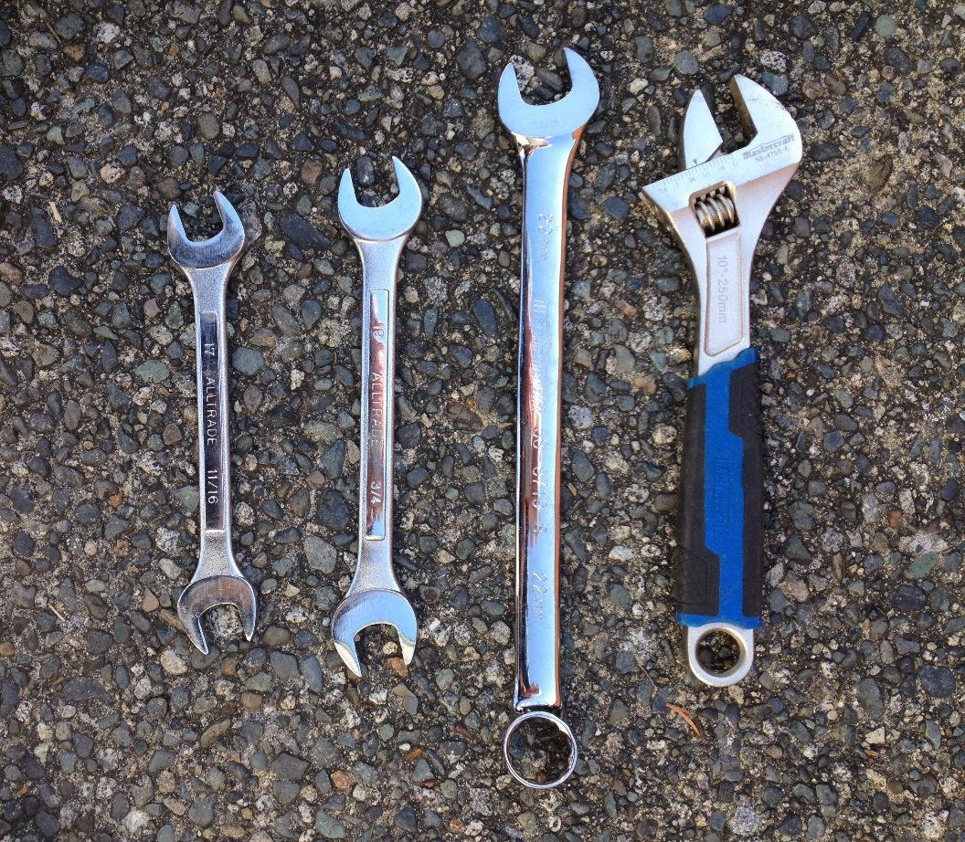
Wrench
A wrench is used to apply torque to turn objects—usually rotary fasteners, such as nuts and bolts—or to keep them from turning. The most common shapes are called open-end wrench and box-end wrench.

Hammer
A hammer is a tool with a weighted head fixed to a long handle used to deliver impact to a small area of an object.
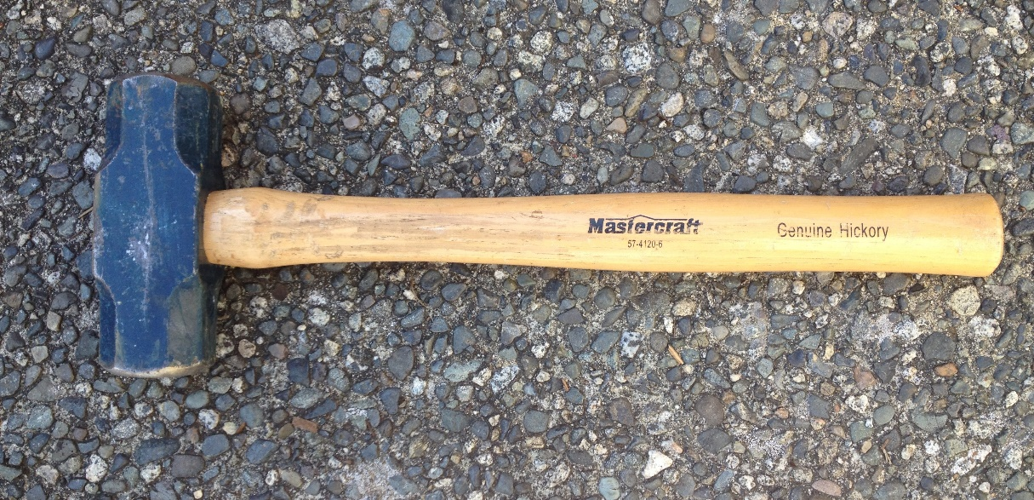

Shovel
A shovel is a tool for digging, lifting, and moving bulk materials, such as soil, gravel, snow, or sand. Most shovels are hand tools consisting of a broad blade fixed to a handle. Shovel blades are usually made of sheet steel or hard plastics. Shovel handles are usually made of wood or fibreglass.
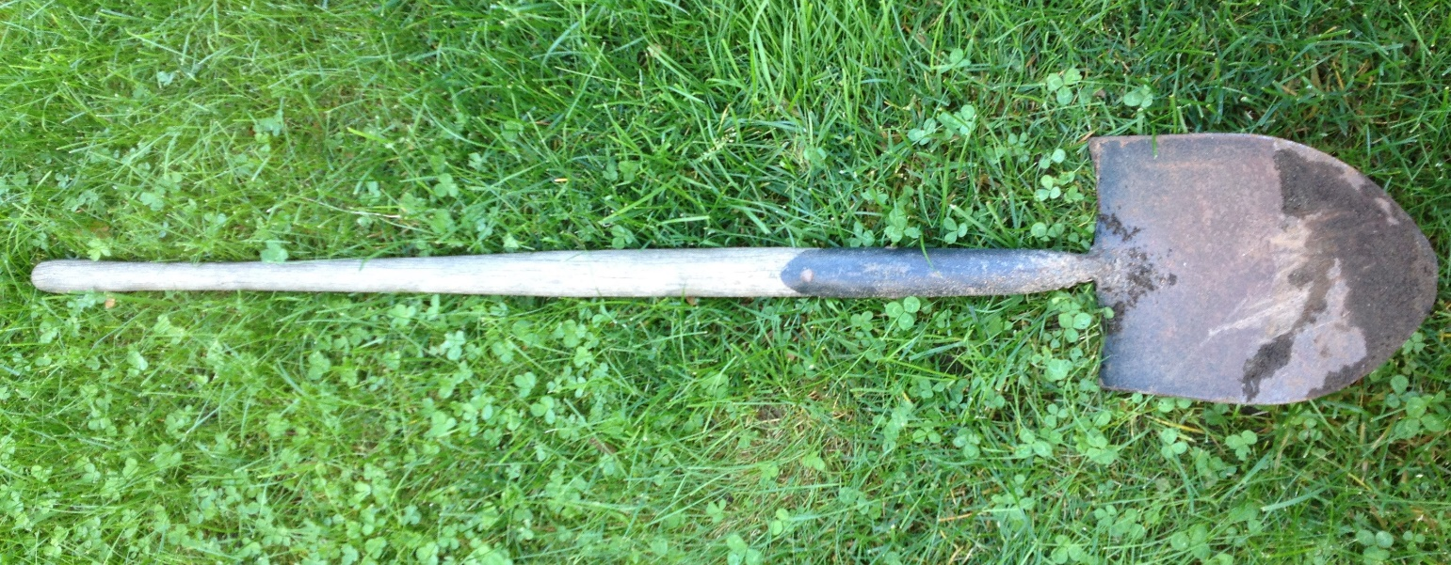

Chisel
A chisel is a tool with a shaped blade designed to carve or cut a hard material such as wood, stone, or metal. The handle is typically made of wood and the chisel is made of metal. The chisel handle is struck with a mallet or hammer to create the chiseling effect.
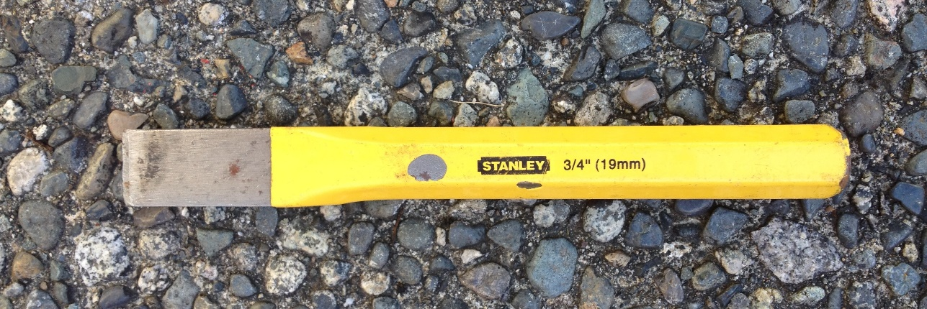

File
A file is a tool used to remove small amounts of metal or wood using an abrasive surface. Most are hand tools, made of steel with a rectangular, square, triangular, or round cross-section. One or more surfaces have sharp teeth.
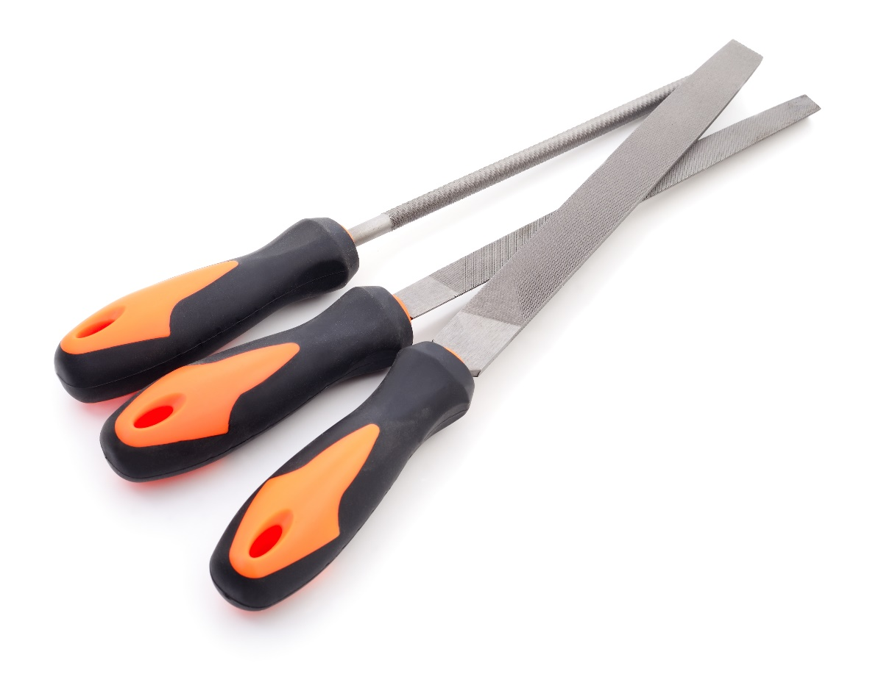

Jack
A jack, screw jack, or jackscrew is a device to lift heavy loads or to apply strong force. A mechanical jack uses a screw thread to lift heavy equipment. A hydraulic jack uses hydraulic power. The most common form is a car jack, floor jack or garage jack, which lifts vehicles to do maintenance. Jacks are usually rated for a maximum lifting capacity.
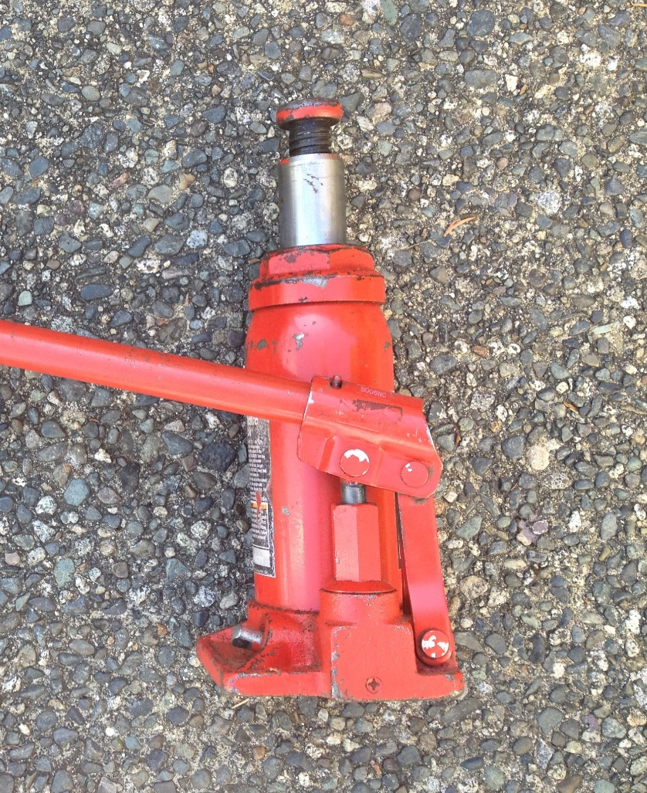

Ratchets
A ratchet is a mechanical device that allows continuous linear or rotary motion in only one direction while preventing motion in the opposite direction. The ratchet has a round gear, or a linear rack with teeth, and a pivoting, spring-loaded finger called a pawl that engages the teeth.
Ratchets are used in:
- Jacks
- Slacklines
- Tie down straps
- Caulking guns
- Grease guns
- Cable ties

Air Tools
An air or air-powered tool is a power tool driven by compressed air. Air tools can be driven by compressed carbon dioxide (CO2) stored in small cylinders (for portability). Compared to electric power tools, they are safer to run and maintain, without risk of sparks, short-circuiting or electrocution. They also have a higher power to weight ratio, allowing a smaller, lighter tool to accomplish the same task.

Specialty Tools
Specialty tools are tools that are used for a highly specific job and/or are designed to be used for one kind of work (for example, welding). Sometimes, specialty tools are designed and used on only one specific brand of machine. Unlike common tools, these tools are used less frequently.
Special tools include the following:
- Multi-testers
- Inspection mirrors
- Pick up magnets
- “Easy Outs”
- Taps and dies
- Drift and pry bars
- Impact wrench
- Greaser
- Hose press
Learning Point
A specialty tool is used for removing the pins that hold excavator bucket teeth on the bucket. As the teeth wear on rocks and hard surfaces, they are replaced. A special tool is used to replace the tight pressure fit pin that holds the tooth to the bucket.

Multi-Testers
A multi-tester is an electronic measuring instrument that combines several measurement functions in one unit. A multi-tester measures voltage, current, and resistance.
Analog multi-testers use a microammeter with a moving pointer to display readings. Digital multi-testers have a numeric display and may show a bar representing the measured value.
Digital multi-testers are more common due to cost and precision, but analog multimeters are still preferred when monitoring a rapidly varying value.
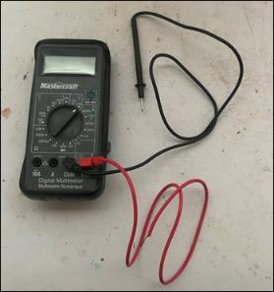

Inspection Mirrors
An inspection mirror is used to help see into difficult or dangerous areas. Some mirrors have light fittings to illuminate dark areas. Inspection mirrors are often used by mechanics to see into engines and under vehicles. Large mirrors can also be used to see into hard to reach places like deep trenches.

Pick Up Magnets
Pick up magnets are tools with a handle and a magnetic end to pick up metal objects. They come in various sizes including small and extendable to reach into hidden spaces. They are often used to pick metal hardware that has fallen out of reach or in a tight area.

“Easy Outs”
An "easy out" is a tool that is used to remove broken or seized screws.
There are two types: one has a spiral flute and the other has a straight flute. Screw extractors are intentionally made of hard, brittle steel.
If too much torque is applied, the tool can break off inside the screw being removed.
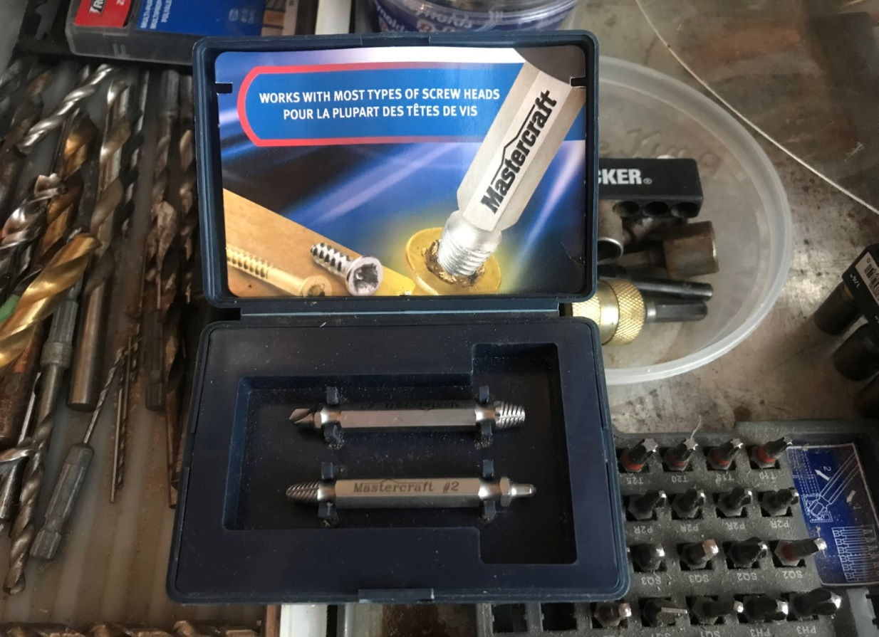

Taps and Dies
Taps and dies are tools used to create screw threads. Some are cutting tools and others are forming tools. A tap cuts or forms the female of the pair (for example, a nut). A die cuts or forms the male of the pair (for example, a bolt).
The process of cutting or forming threads using a tap is called “tapping”. The process using a die is called “threading”. Both tools can be used to clean up a thread, which is called “chasing”.
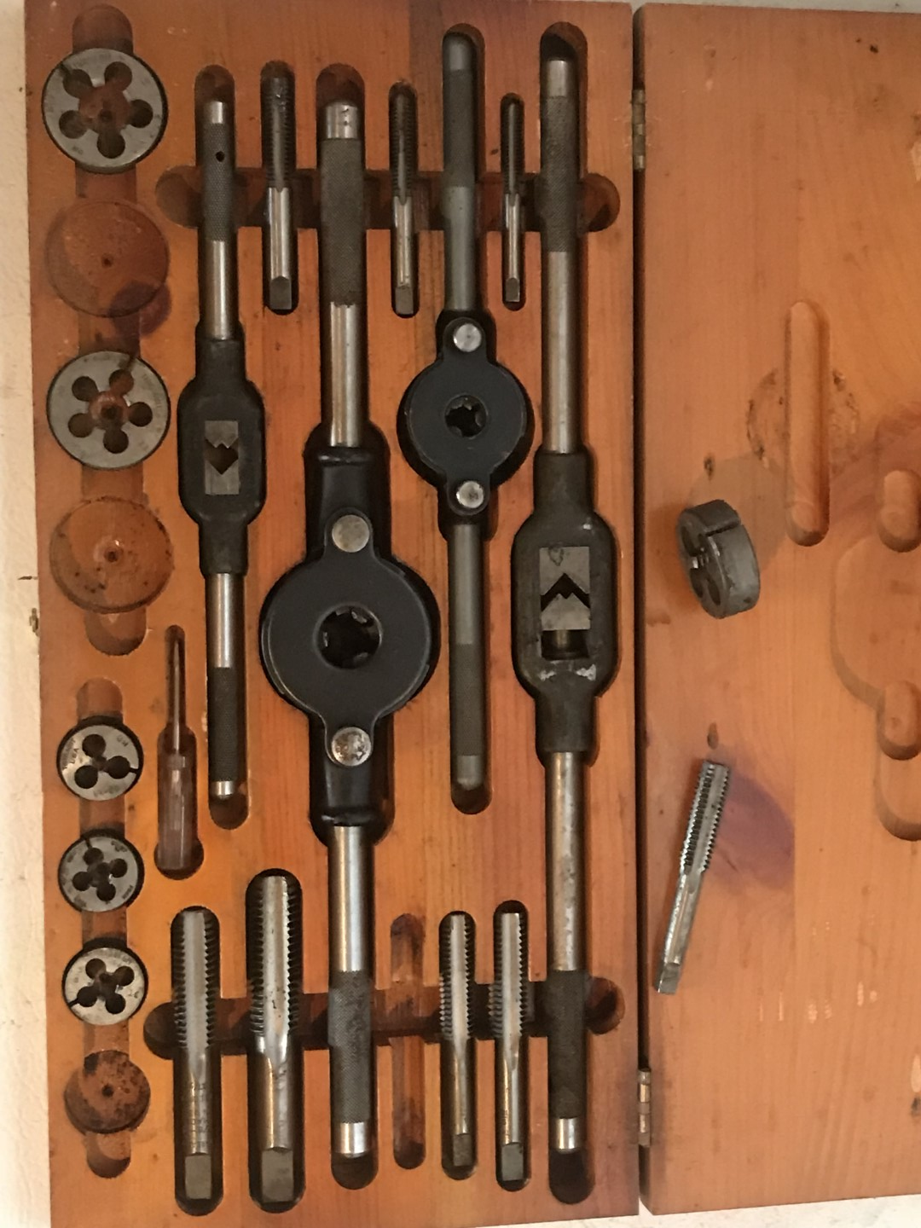

Drift and Pry Bars
A pry bar is a long steel bar, usually pointed on one end and flat on the other, like a big slot screw drive. The bar is used to move heavy parts and “pry” equipment pieces apart when working on them.

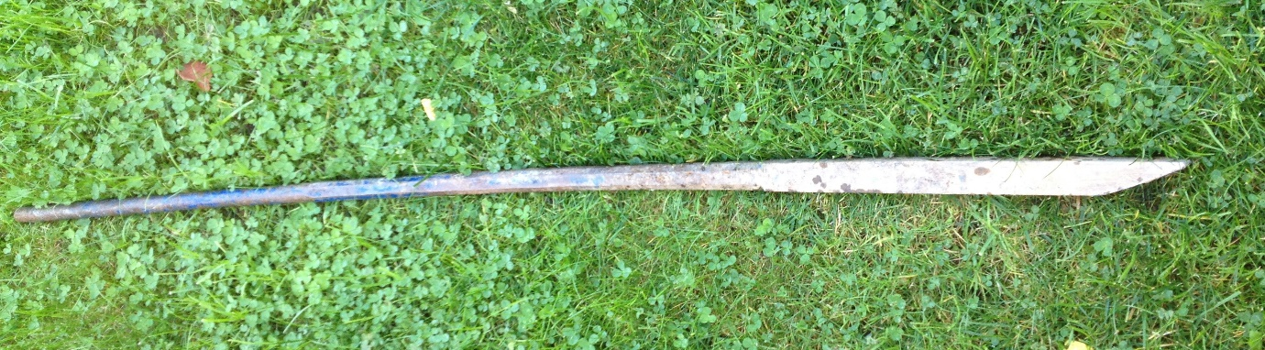
A drift bar is a pin inserted between two equipment components to hold them together. The pin is almost always a tight friction fit on one component and a slightly loose fit on the other. This allows for greasing and movement. The pin is hammered into the hole on the tight-fitting component and a specialty tool is used to remove the drift pin when needed.

Impact Wrench
An impact wrench is a socket wrench power tool designed to give high torque output with minimal effort. Compressed air is the most common power source, although electric or hydraulic power is also used. Impact wrenches are widely used for heavy equipment maintenance and any other project where a high torque output is needed.
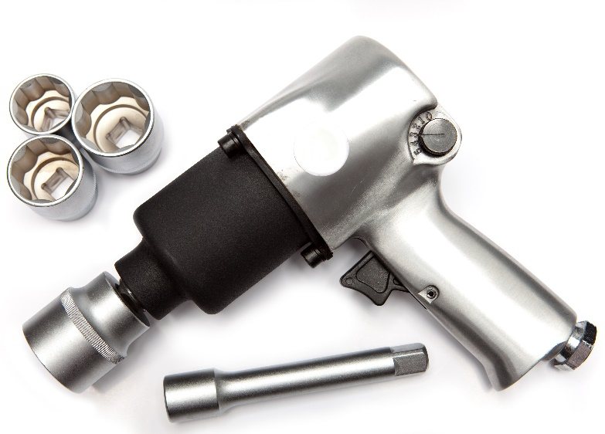

Die grinder
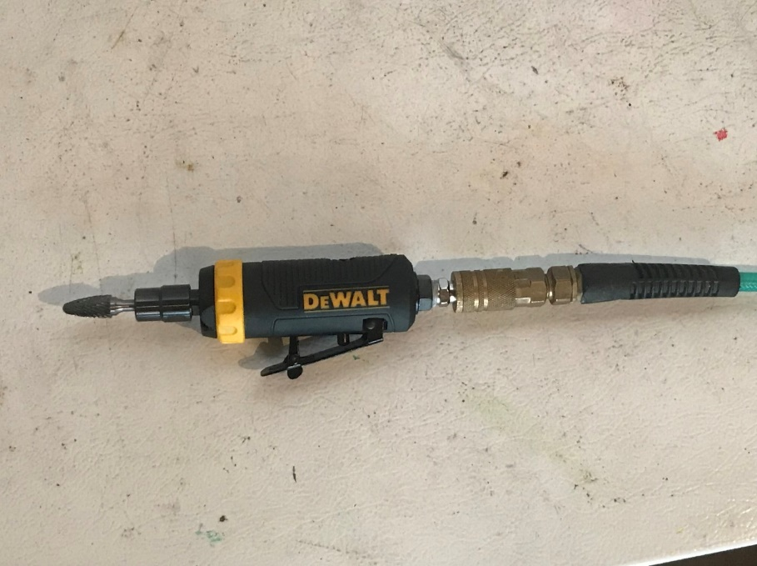
Die grinders are handheld power tools used for grinding, sanding, honing, polishing, or machining material such as metal, plastic, or wood. They are usually pneumatically driven, heavy-duty tools. The die grinder gets its name from tool and die work, where they were used to create the exact lines of dies or molds.

Greaser
A grease gun is a tool used for lubrication. The purpose of the grease gun is to apply lubricant through to a specific point, usually on a grease fitting or “nipple.” The channels behind the grease nipple lead to where the lubrication is needed. The close fit of the opening ensures that lubricant is applied only where needed.
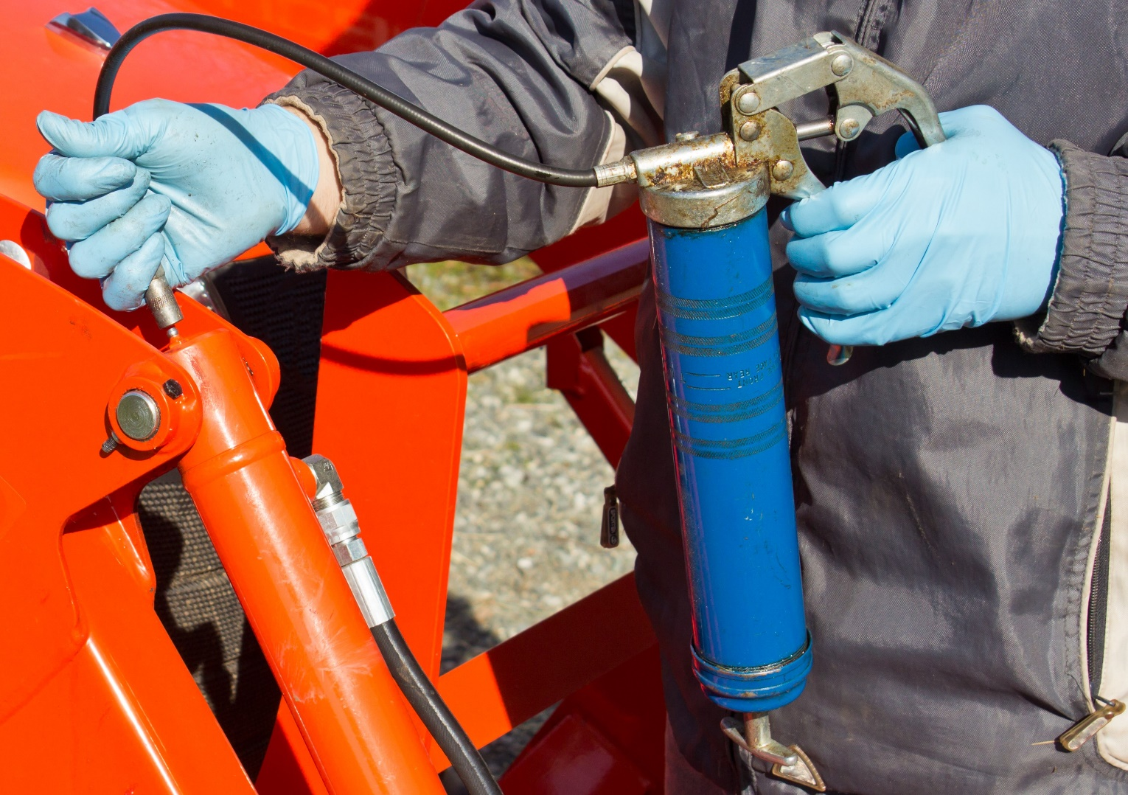
There are four types of grease gun:
- hand-powered with trigger
- hand-powered without trigger
- air-powered
- electric

Hose Press
A hose press is a hydraulic press that clamps the metal fittings onto the ends of rubber type hoses for hydraulic fluid or other fluid movement in a machine. The metal fittings that are “pressed” onto the end of the hose usually have a threaded end so they can be connected to equipment components or other hoses.

Common and Specialty Tools Used on Heavy Equipment—Self-Quiz
- A multi-tester is an electronic measuring instrument that measures:
- Voltage and current
- Current and resistance
- Voltage, current, and distance
- Voltage, current, and resistance
- An "easy out" is a tool that is used to:
- Remove embedded nails
- Remove broken or seized screws and bolts
- Remove clamps from a hose
- All of these answers
Now check your answers on the next page.

Common and Specialty Tools Used on Heavy Equipment—Self-Quiz Answers
- A multi-tester is an electronic measuring instrument that measures:
Answer: Voltage, current, and resistance
- An "easy out" is a tool that is used to:
Answer: Remove broken or seized screws and bolts

Section 1081-02: Welding Equipment and Supplies
What you will learn in this section
2.1 Welding equipment and supplies used on heavy equipment
2.2 Types of welding used on heavy equipment
2.3 PPE required when using welding equipment

Key Point 2.1: Welding Equipment and Supplies Used on Heavy Equipment
The following are welding equipment used on heavy equipment:
- Oxy acetylene cutting system
- Propane gas torch
- Chip hammer or flux hammer
- Wire brush
- Grinder
- Drill
- Cut-off saw
- Air tool
- Flux chipper
- Cutting table
- Plasma cutter
- Vice

Oxy Acetylene Cutting System
Oxy-fuel cutting is a system that uses fuel gases and oxygen to cut metals. Pure oxygen, instead of air, is used to increase the flame temperature to focus melting of a material, like steel. A torch is used to heat metal to its kindling temperature. A stream of oxygen is then trained on the metal, burning it into a metal oxide that flows out as slag.
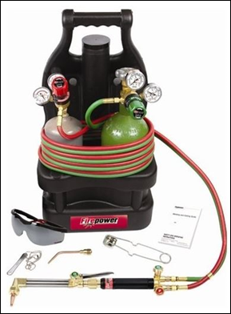

Propane Gas Torch
A propane torch is used for the application of flame or heat and uses propane for fuel. The propane torch can be a hand-held burner with a small attached tank or an industrial torch which has separate fuel and pure oxygen tanks to feed the flame with 100% oxygen and creates much higher temperatures.
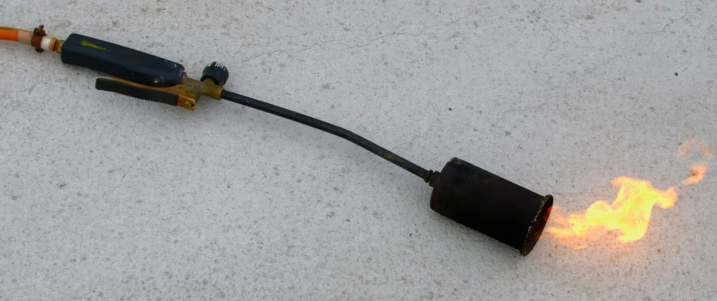

Chip Hammer or Flux Hammer
A chipping hammer is a tool used to remove welding slag from a weld and welding spatter from alongside welds.
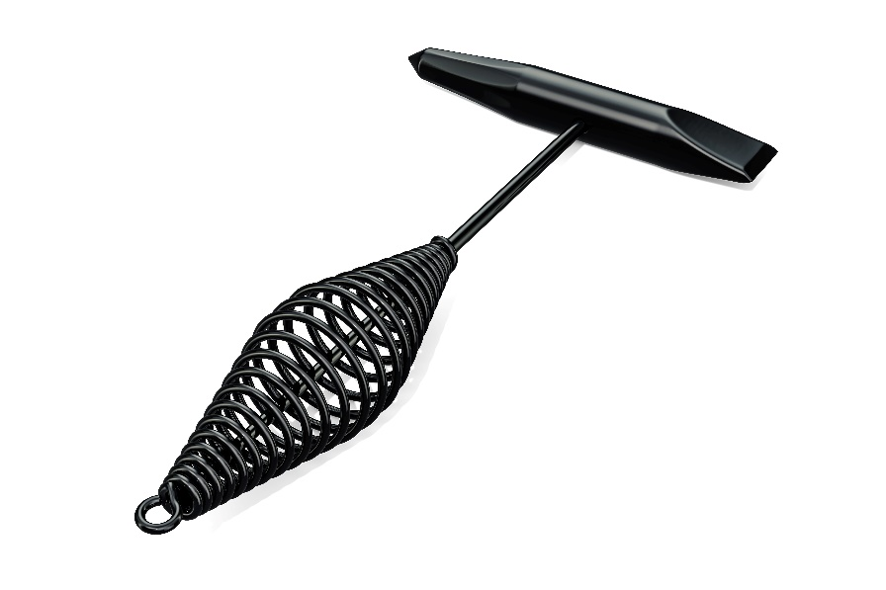

Wire Brush
A wire brush is a brush whose bristles are made of wire, usually steel, and are hard and springy. The brush is an abrasive tool, used for cleaning off rust and removing paint prior to welding. It is also used to clean surfaces and create a better conductive area for attaching electrical connections, when they have built up grime and dirt.
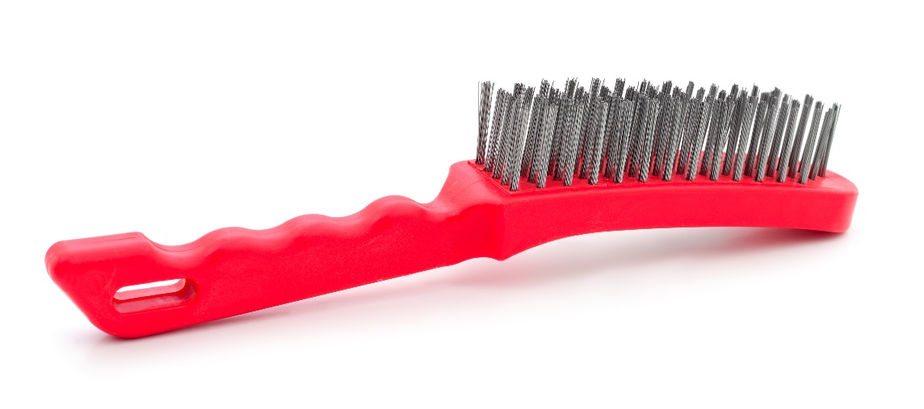

Grinder
An angle grinder, also known as a side grinder or disc grinder, is a handheld power tool used for grinding and polishing. Angle grinders may be used for removing excess material from a piece. There are many different kinds of discs that are used for various materials and tasks, such as cut-off discs (diamond blade), abrasive grinding discs, grinding stones, sanding discs, wire brush wheels, and polishing pads.
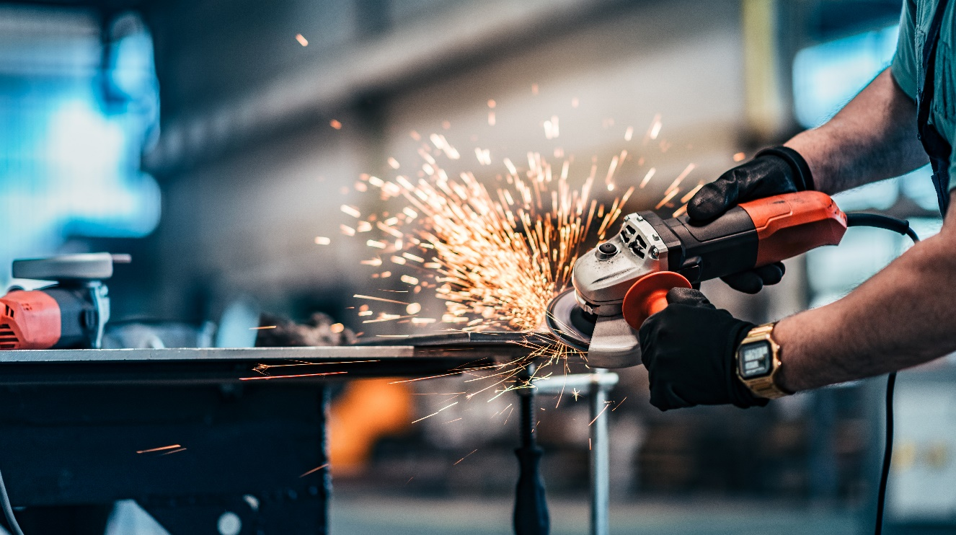

Drill
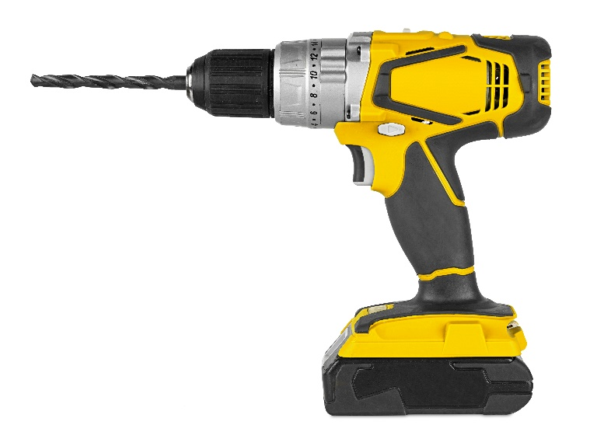
A drill is a tool used for making round holes or driving fasteners. It is fitted with a bit, either a drill or driver, secured by a chuck. Some powered drills also include a hammer function. Drills vary widely in speed, power, and size. They are either electric-powered with cords or battery-powered without cords.

Cut-off Saw
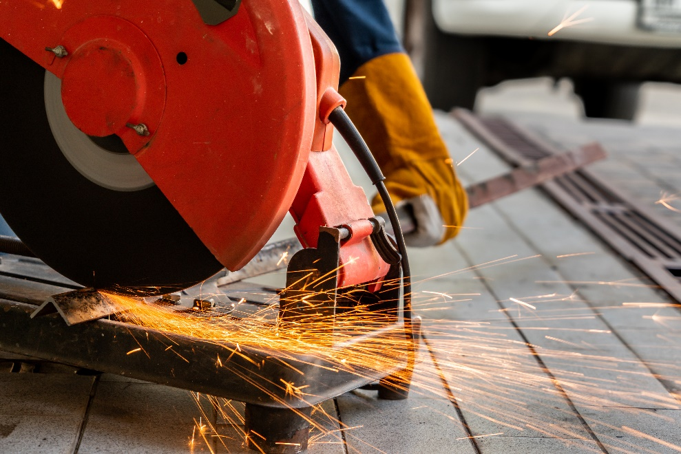
An abrasive saw, also known as a cut-off saw or chop saw, is a power tool used to cut hard materials, such as metal, tile, and concrete. An abrasive disc cuts through metal, similar to a thin grinding wheel. These saws are available in table top, free hand, and walk behind models. Abrasive saws use composite friction disk blades to abrasively cut through the material.

Air Tool
An air or air-powered tool is a power tool driven by compressed air. Air tools can be driven by compressed carbon dioxide (CO2) stored in small cylinders (for portability). Compared to electric power tools, they are safer to run and maintain, without risk of sparks, short-circuiting or electrocution. They also have a higher power to weight ratio, allowing a smaller, lighter tool to accomplish the same task.

Flux Chipper
A flux chipper is ideal for removal of flux, spatter and general scaling. This chipper removes the coating on a weld after the metal has cooled (which is called flux). The chipper is a little specialty hammer that is used to tap on the weld to pop off the flux.
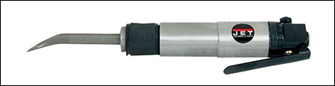

Cutting Table
A plasma cutting table is a support table made of a grid of bars that can be replaced. Plate steel is loaded on a table and the parts are cut out as programmed. Some expensive burn tables also include CNC punch capability, with a carousel of different punches and taps.

Plasma Cutter
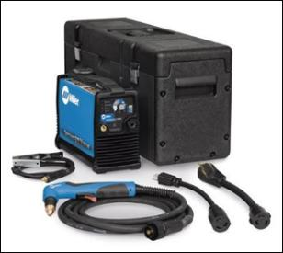
A plasma cutter cuts through electrically conductive materials using an accelerated jet of hot plasma. Typical materials cut with a plasma torch include steel, stainless steel, aluminum, brass and copper. The process involves creating an electrical channel of superheated, electrically ionized gas (plasma) from the cutter through the metal and back to the cutter via a grounding clamp.

Vice
A vice is a mechanical device used to secure an object to work on. Vices have two parallel jaws, one fixed and the other movable, threaded in and out by a screw and lever. Vices used in metalworking usually have serrated jaws to get a better grip on metal.
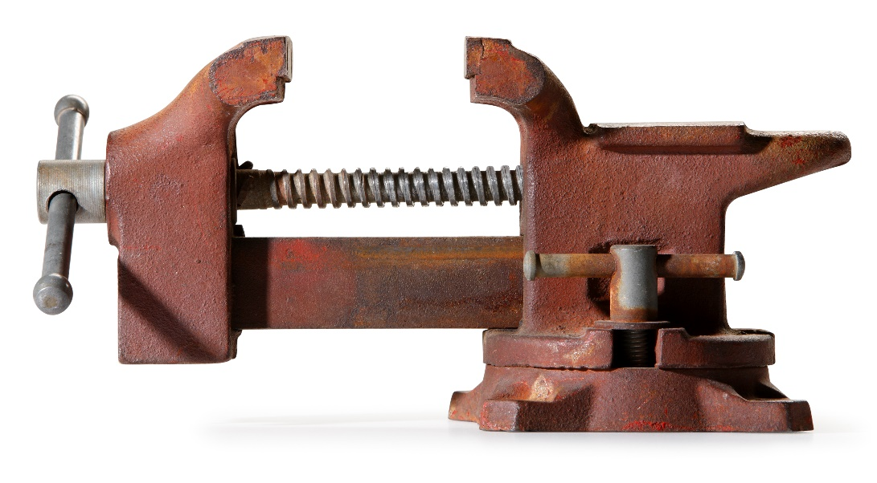

Welding Supplies Used on Heavy Equipment
The following are welding supplies used on heavy equipment:
- Chalk
- Tip cleaner
- Air arc

Chalk
Soapstone chalk is used in welding because the heat-resistant powder does not burn away. The chalk continues to be visible when the workpiece is heated during the welding process.

Tip Cleaner
Tip cleaners are used to clean the cutting and welding tips on oxygen-acetylene torches. The cleaners come in multiple sizes and models, including standard length wire tip cleaners and extra-long wire tip cleaners. Using tip cleaners assures a better-quality flame and extends the life of the torch.

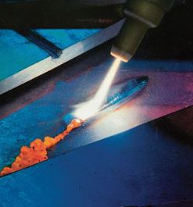
Air Arc
An air arc is a torch used to cut and melt metal by the heat of a carbon arc. Molten metal is then removed by a blast of air. It uses a consumable carbon or graphite electrode to melt the metal, which is then blown away by an air jet.

Welding Equipment and Supplies Used on Heavy Equipment—Self-Quiz
- A flux chipper is a specialty hammer used to:
- Create flux in a plasma stream
- Chip paint off metal
- Remove the coating on a weld
- None of these answers
- An angle grinder is also known as a:
- Side grinder
- Round grinder
- Polish grinder
- Back grinder
Now check your answers on the next page.

Welding Equipment and Supplies Used on Heavy Equipment—Self-Quiz Answers
- A flux chipper is a specialty hammer used to:
Answer: Remove the coating on a weld
- An angle grinder is also known as a:
Answer: Side grinder

Key Point 2.2: Types of Welding Used on Heavy Equipment
The following are the types of welding used on heavy equipment:
- Stick welding
- Wire feed
- Brazing

Stick welding
Stick welding is a manual arc welding process that uses an electrode covered with a flux to lay the weld. An electric current, either an alternating or a direct current from a welding power supply, is used to form an electric arc between the electrode and the metals to be joined.
The work piece and the electrode melt to make a pool of metal that cools to form a joint. As the weld is laid, the electrode’s flux coating disintegrates, giving off vapors that make a shielding gas and providing a layer of slag. These protect the weld area from atmospheric contamination.

Wire feed
Wire feed welders use a continuous wire electrode on a spool. Rollers in the welder driven by a motor feed the wire at a steady rate through an electrode holder, usually called a gun. Wire feed welders were invented to increase production rates by removing the need to stop and replace a burned electrode.

Brazing
Brazing is a metal-joining process where two or more metal pieces are joined by melting and flowing a filler metal into the joint. The filler metal has a lower melting point than the other metals.
The filler flows into the gap between close-fitting parts by capillary action. The filler is then brought slightly above its melting temperature while protected by a suitable atmosphere, usually a flux. The filler flows over the base metal and is cooled to join the pieces together.

Types of Welding Used on Heavy Equipment—Self-Quiz
- Wire feed welders were invented to increase:
- Production rates
- Electrical current
- Speed of current
- None of these answers
- Brazing is a metal-joining process where two or more metal pieces are joined by:
- Melting the two pieces together
- Fixing the two pieces with a clamp
- Melting and flowing a filler metal into the joint
- None of these answers
Now check your answers on the next page.

Types of Welding Used on Heavy Equipment—Self-Quiz Answers
- Wire feed welders were invented to increase:
Answer: Production rates
- Brazing is a metal-joining process where two or more metal pieces are joined by:
Answer: Melting and flowing a filler metal into the joint

Key Point 2.3: Personal Protective Equipment (PPE) Required When Using Welding Equipment
When welding, safety is of vital importance to prevent injury. The different forms of light and radiation can cause injuries that are not immediately obvious. PPE such as gloves, helmets, and goggles are critical to keep welders from being harmed on the job.

Gloves
Welding gloves are PPE that protect the hands of welders from the hazards of welding. These gloves allow finger articulation while protecting the operator from electrical shock, extreme heat, and ultraviolet and infrared radiation, and also provide abrasion resistance and enhanced grip.

Welding Helmet
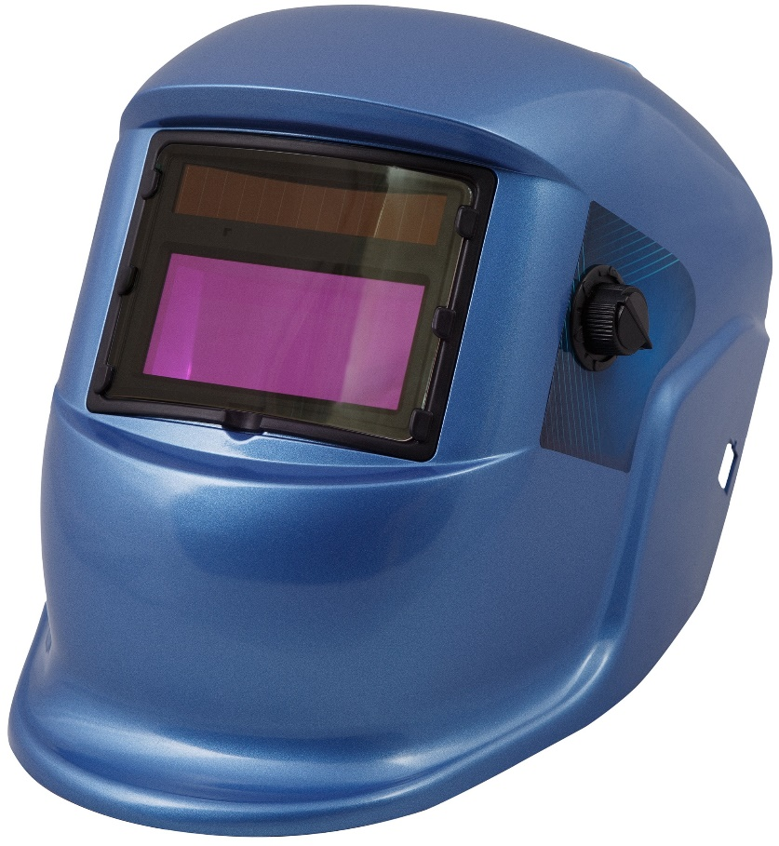
A welding helmet is headgear worn when welding to protect the eyes, face and neck from flash burn, ultraviolet light, sparks, infrared light, and heat. These helmets are commonly used with arc welding. They are necessary to prevent arc eye, a painful condition where the cornea is inflamed. Helmets can also prevent retina burns, which can lead to a loss of vision.

Cutting Goggles
Cutting goggles provide eye protection while welding and cutting. They protect the eyes from the heat and optical radiation produced by the welding, such as the intense ultraviolet light produced by an electric arc. They also protect from sparks and debris. UV and IR waves cannot be seen and can produce eye injury without the welder realizing it. Extremely dark filters are needed to be able to look at the glowing metal.
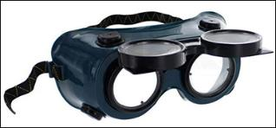

Respiratory Protection
Respiratory protection may be required if ventilation measures and work practices do not reduce potential exposures of welding fumes to safe levels.

Body Protection
Wear oil-free protective clothing made of wool or heavy cotton. Heavier materials work best. They are harder to ignite and resist wear and damage.
Reference
WorkSafeBC
Read General welding and cutting
https://www.worksafebc.com/en/resources/health-safety/toolbox-meeting-guides/general-welding-and-cutting-requirements?lang=en
When you are finished, continue in this section.

PPE Required When Using Welding Equipment—Self-Quiz
- Welding gloves protect the operator from:
- Electrical shock
- Extreme heat
- Ultraviolet and infrared radiation
- All of these answers
- Cutting goggles provide protection from:
- Heat, radiation, sparks and debris
- Heat and radiation
- Heat and sparks
- Sparks and debris
Now check your answers on the next page.

PPE Required When Using Welding Equipment—Self-Quiz Answers
- Welding gloves protect the operator from:
Answer: All of these answers
- Cutting goggles provide protection from:
Answer: Heat, radiation, sparks and debris

Section 1081-03: Gas Powered Tools
What you will learn in this section
3.1 Gas powered tools used on heavy equipment

Key Point 3.1: Gas-Powered Tools Used on Heavy Equipment
The following are gas-powered tools used on heavy equipment:
- Two stroke engines
- Four stroke engines
- Cut-off saw
- Chainsaw
- Pressure washers
- Gas and electric compressors
- Gas and diesel generators
- Pumps
- Plate compactor

Two Stroke Engines
A two-stroke engine is an internal combustion engine that finishes a power cycle with two strokes (up and down) of the piston during only one crankshaft revolution. The end of the combustion stroke and the beginning of the compression stroke happen at the same time. Two-stroke engines have a high power-to-weight ratio. They also have fewer moving parts, so are more compact and lighter.
Mixed gas (gasoline combine with 2 stroke engine oil) is required

Four Stroke Engines
A four-stroke engine is an internal combustion engine in which the piston completes four separate strokes while turning the crankshaft. A stroke refers to the full travel of the piston along the cylinder, in either direction. The four separate strokes are intake, compression, combustion, and exhaust.
Straight gas is required.

Cut-off saw
A cut-off saw, or chop saw, is a power tool typically used to cut hard materials like metal, tile, and concrete. The cutting action is performed by an abrasive disc, similar to a thin grinding wheel. These saws are available in different models, including table top, free hand, and walk behind.

Chainsaw
A chainsaw is a portable, mechanical saw that cuts using a set of teeth attached to a rotating chain that runs along a guide bar. Specialized chainsaws are also used for cutting concrete.
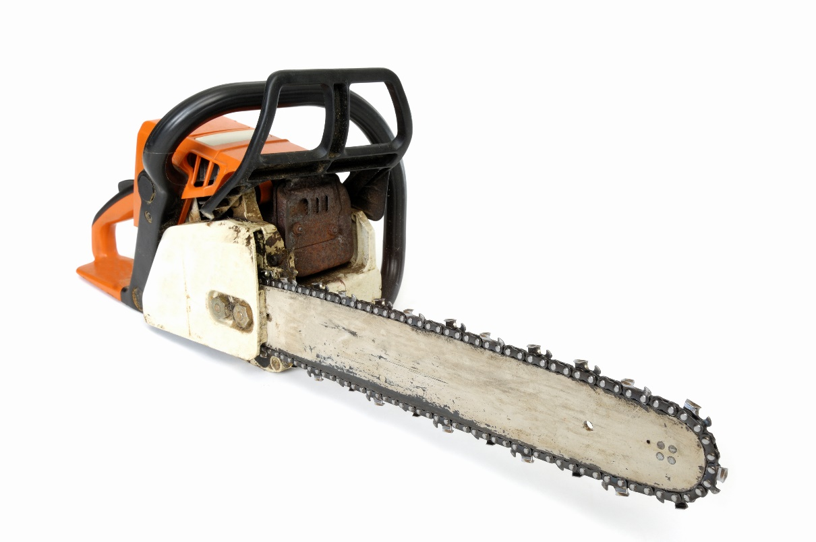

Pressure Washers
Pressure washers are tools that spray high-pressure water to remove paint, mold, grime, dust, mud, and dirt from surfaces and objects. The volume of a mechanical pressure washer is measured in gallons or litres per minute and is often designed into the pump. The pressure (expressed in pounds per square inch) is designed into the pump but can be varied. Pressures range from 750 to 3,000 psi.

Gas and Electric Compressors
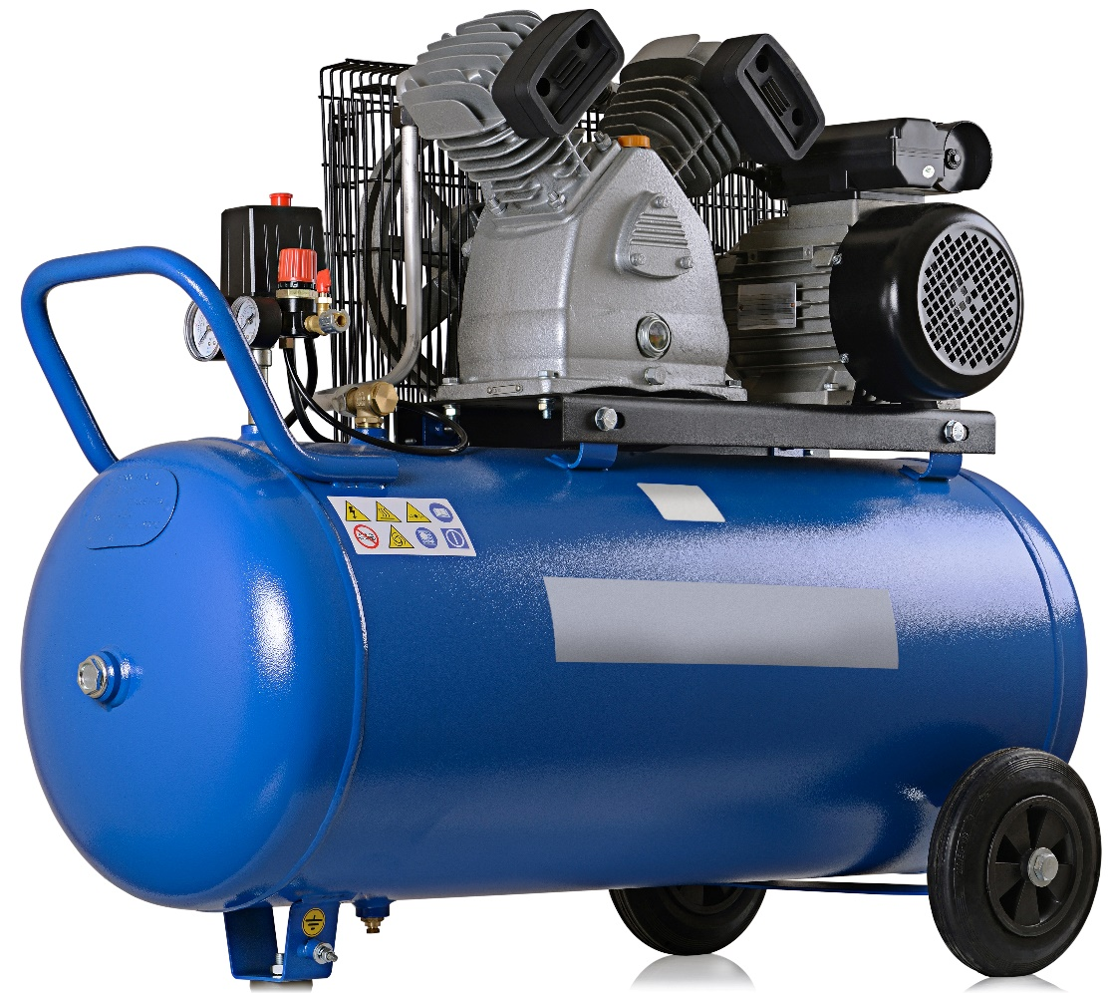
An air compressor converts power (using an electric motor, diesel, or gasoline engine, etc.) into energy stored in pressurized air. An air compressor forces air into a storage tank, increasing the pressure. When tank pressure reaches its engineered limit, the air compressor shuts off. The compressed air, then, is held in the tank until used. The energy contained in the compressed air can have different uses, commonly for air powered tools. When the air is released, the tank depressurizes. When tank pressure reaches its lower limit, the air compressor turns on again and re-pressurizes the tank.
A gas or diesel compressor is fueled by gas or diesel, while an electric compressor powered by electricity.

Gas and Diesel Generators
A portable generator is the combination of an electrical generator and an engine mounted together to form one piece of equipment. Generators are available in a wide range of power ratings. These include small, hand-portable units that supply several hundred watts of power, hand-cart mounted units, that supply several thousand watts and stationary or trailer-mounted units that supply over a million watts.
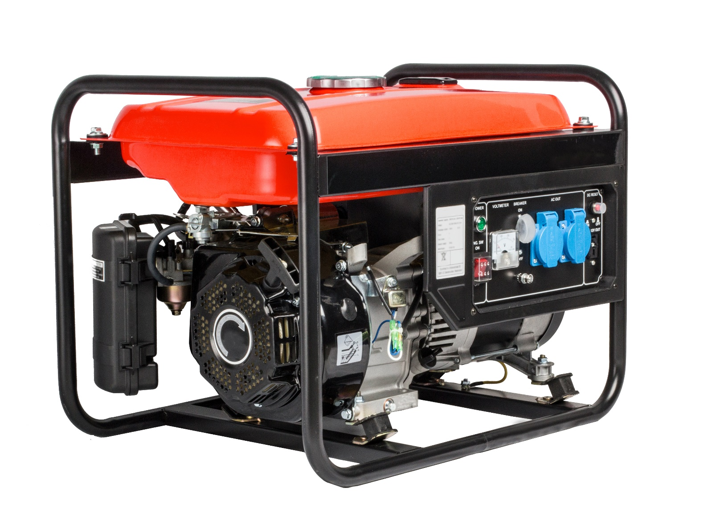
A gas generator is fueled by gas, typically smaller units. Diesel generator is fueled by diesel, typically larger units.
Use caution with any gas or diesel powered tools when used in enclosed areas or sites with poor air movement. Carbon monoxide is difficult to detect as it is a colourless and odorless gas that is part of engine exhaust. Carbon monoxide poisoning can occur within minutes and causes unconsciousness and death. Early signs of carbon monoxide poison include dizziness, headaches and nausea.

Pumps
A pump is a device that moves fluids (liquids or gases) by mechanical action. There are three kinds of pumps, depending on the way they use to move the fluid: direct lift, displacement, and gravity pumps. Pumps operate by a mechanism (reciprocating or rotary) and consume energy to move the fluid. They operate by using different energy sources including manual operation, electricity, engines, or wind power.

Plate Compactor
A compactor is a machine or mechanism used to reduce the size of material through compaction. The plate compactor has a large vibrating baseplate and is used for creating a level grade.
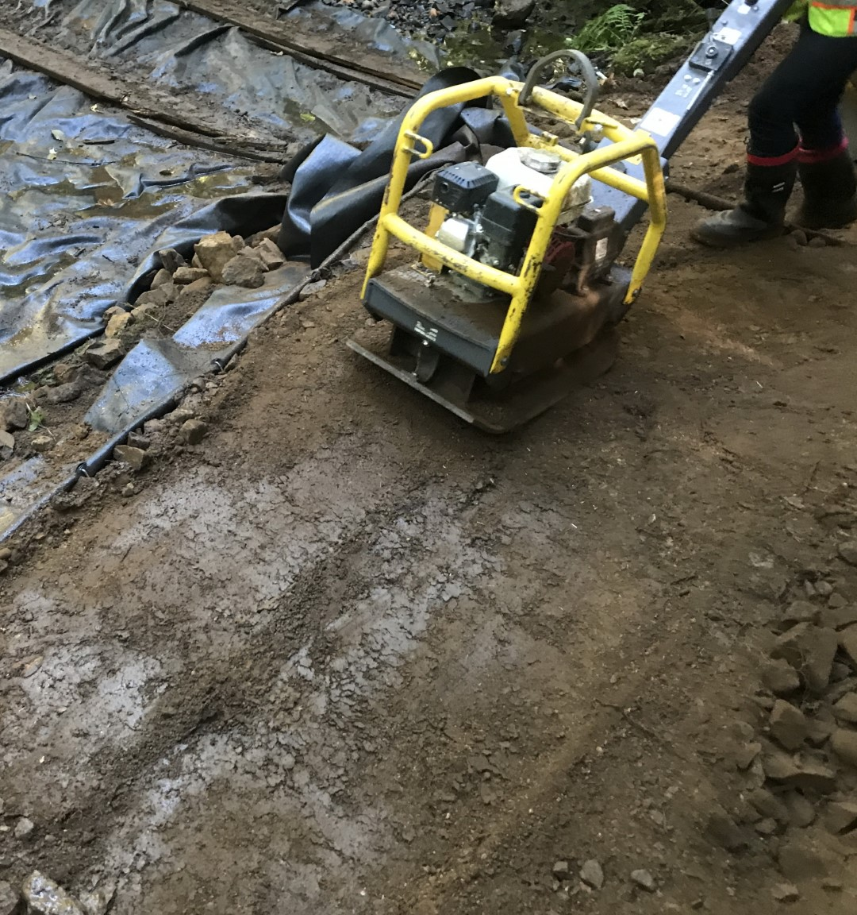

Gas-Powered Tools Used on Heavy Equipment—Self-Quiz
- With a two-stroke engine, the end of the combustion stroke and beginning of the compression stroke happen:
- At the same time
- 3 seconds apart
- 5 seconds apart
- 7 seconds apart
- Pressures in a pressure washer range from:
- 500 to 10,000 psi
- 750 to 3,000 psi
- 1000 to 40,000 psi
- None of these answers
Now check your answers on the next page.

Gas-Powered Tools Used on Heavy Equipment—Self-Quiz Answers
- With a two-stroke engine, the end of the combustion stroke and beginning of the compression stroke happen:
Answer: At the same time
- Pressures in a pressure washer range from:
Answer: 750 to 3,000 psi

Section 1081-04: Lubricants
What you will learn in this section
4.1 Lubricants used on heavy equipment and their application

Key Point 4.1: Lubricants Used on Heavy Equipment and their Application

Lubricants Used on Heavy Equipment
The following are lubricants used on heavy equipment:
- Grease
- Oil
- Specialty oil

Grease
Grease is a semisolid lubricant that typically consists of a soap emulsified with mineral or vegetable oil. Greases are applied to mechanisms that can only be lubricated infrequently and where lubricating oil would not stay in place. They also act as sealants to prevent ingress of water and debris.

Oil
Oil is a viscous liquid that repels water and can be mixed with other oils. Oils do not easily adhere to other substances. This makes them useful as lubricants for various purposes. Mineral oils are more commonly used as machine lubricants. Oils also have a high carbon and hydrogen content and are flammable.
Oils are used in heavy machinery for the:
- engine
- gears
- hydraulics

Specialty Oil
Specialty oils can include items such as “bio” or vegetable oils used in place of hydraulic oils. These are ideal when working in streams and lakeshore areas with equipment as there is less chance of damage to fish and aquatic life if there is a leak.
Learning Point
Grease has a high initial viscosity. When applied, this high-level drops to about the same viscosity as the base (mineral or vegetable) oil in the grease.

Applications
The safe application and use of various lubricants are determined by their viscosity and their Safety Data Sheet (SDS).

Viscosity
The viscosity of a fluid is the measure of its resistance to gradual degradation by shear stress or tensile stress. For liquids, it is similar to the informal concept of "thickness." For example, oil has a higher viscosity than water. Viscosity is caused by friction between the molecules of a fluid and is measured with various viscometers and rheometers.

Safety Data Sheet
A safety data sheet (SDS) is a document that lists occupational safety and health information for various products. SDSs may include instructions for the safe use and/or potential hazards of product, along with spill-handling procedures. Substances must be properly labelled to reduce health or environmental risk on the job.

Lubricants Used on Heavy Equipment and their Application—Self-Quiz
- Specialty oils are used when:
- Working in streams and lakeshore areas
- Working in Alberta’s oil country
- Working in high elevation
- None of these answers
- Safety data sheets may include:
- Occupational safety and health information
- Spill handling procedures
- Safe use and/or hazards of products
- All of these answers
Now check your answers on the next page.

Lubricants Used on Heavy Equipment and their Application—Self-Quiz Answers
- Specialty oils are used when:
Answer: Working in streams and lakeshore areas
- Safety data sheets may include:
Answer: All of these answers

Section 1081-05: Common Supplies
What you will learn in this section
5.1 Common supplies used on heavy equipment

Key Point 5.1: Common Supplies Used on Heavy Equipment
The following are common supplies used on heavy equipment:
Categories | Supplies
Maintenance fluids | De-icer  Methyl hydrate  Starting fluid  Antifreeze  Brake cleaner
Tapes and ties | Duct tape  Insulating tape  ‘Hay’ wire  Cable ties  Tie downs
Connecting hardware | Nuts and bolts  Washers  Screws  Rivets  Pins hose clamps
Fluid transporting and sealing components | O-rings  Seals  Grease nipples  Pipefittings  Grommets  Hydraulic hoses
Ground engaging disposables | Bucket teeth  Pins  Locks  Corner bits  Cutting edges

Common Supplies Used on Heavy Equipment—Self-Quiz
- A common maintenance fluids is:
- Oil
- Grease
- Anti-freeze
- All of these answers
- Common connecting hardware includes:
- Bolts
- Screws
- Rivets
- All of these answers
Now check your answers on the next page.

Common Supplies Used on Heavy Equipment—Self-Quiz Answers
- One of the common maintenance fluids is:
Answer: All of these answers
- Common connecting hardware includes:
Answer: All of these answers

