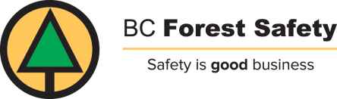

Health Screening Self-Assessment: (Daily)

In order to protect the health and safety of employees, workers, contractors and visitors auditors will perform a health screening assessment before they visit a worksite.

If you answer “yes” to any of these questions, do not visit the worksite.

1. | In the last 14 days, have you had close contact with someone with COVID- 19?  (Eg: Sick family member at home)
2 | In the last 14 days, have you been asked to self-isolate for any reason?  (Eg: Travel, public order as per health authority, etc.)
3. | In the last 14 days, have you been in close contact with someone who has been asked to self-isolate or quarantine?
4. | Within the last 24 hours, have you experienced COVID-19 symptoms?  BC CDC COVID-19 symptoms:  cough, sneeze, fever, sore throat, difficulty breathing  Medical information/support:  • Employees can call anytime to talk to a health care provider at HealthLinkBC (8-1-1) and get advice about how you are feeling and what to do next  - BC Ministry of Health COVID-19 Symptom Self-Assessment Tool: https://bc.thrive.health/covid19/en

