Personal Protective Equipment
- Sturdy appropriate footwear including boot equipped with good soles (Vibram) or caulks if walking woody debris
- High visibility clothing and clothing that is fire resistant (e.g., cotton or wool, not polyesters) or commercially treated (e.g., Nomex)
- Hardhat of a contrasting color
- Fire resistant gloves that are suitable for the type of light up fuel being used; and/or
- Chemical resistant gloves for fuel.
SAFE PROCEDURES
TORCH HANDLING PROCEDURE

- Wear all personal protective equipment before beginning task.
- Fueling to Prepare Special Fuel Mixture by adding #1 diesel to Jet A-1, using three to one ratio.
- Ensure that a 10 lb. ABC fire extinguisher is within reach during all operations of the drip torch.
- Fueling should take place on a non-combustible surface a minimum of 1 square meter (3 square feet) away from any sparks or embers, and a minimum of 30 meters (98 feet) from the ignition operation area.
- Fuel should be premixed in a separate approved gas container and shaken thoroughly prior to fueling the drip torch tank.
- Prepare your drip torch for use by removing the lock ring and spout. Fill the tank ¾ full. This will leave room for expansion. If the tank is filled to the top, leakage will result. Wipe off any fuel that may have spilled onto the outside surface of the tank or handle. Dispose of wiping material well away from the filling site.
- Clothing contaminated with fuel should be replaced prior to torch operation.
Never use gasoline! Explosive vapors may be released from these mixtures. Handle mixtures accordingly.

TORCH IGNITION
- Move from the fueling site and select an area with sufficient duff layer to ignite the torch.
- Except for the fuel being used in the drip torch, all excess fuel should be kept well clear of the ignition operation area.
- Remove the discharge spout sealing plug and screw it into the blind threaded socket.
- Place the spout assembly on the gasket in the mouth of the tank with the spout exposed. Screw the lock ring down securely. (Torch should never be operated without the gasket because it could cause some fuel to leak onto the outside tank and handle surfaces.)
- Shake the torch to ensure the fuel is well mixed.
- Slightly open the breather valve on the tank to allow air into the container and fuel to flow. Check the torch for leaks.
- If fuel leaks from any part of the torch other than the nozzle, empty the fuel into an approved fuel container and return for servicing.
- Light the igniter by igniting a portion of the duff layer and then lower the wick to burning duff to ignite. After the torch is ignited, thoroughly extinguish the duff fire. The torch is now ready to be used.
Tank should not be opened or filled near an open flame, hot coals, sparks or while smoking. The tank may contain dangerous vapors!
TORCH OPERATION
- Hold the torch to your side pointing the igniter away from your body.
- Gradually tilt the torch forward until the fuel pours over the burning igniter casting a flame along the path you are traveling.
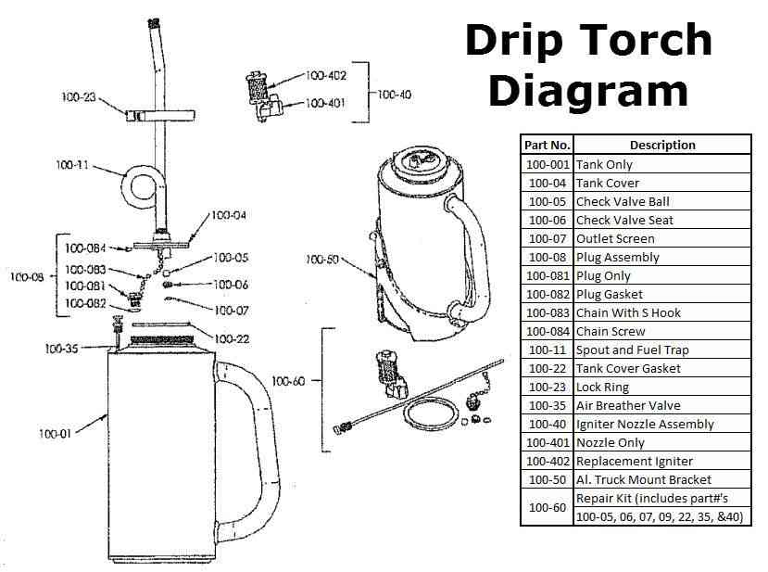
- If no flame carries with discharged fuel, reduce the flashpoint of fuel by increasing the Jet A-1 proportion of the mixture, this operation must be completed back at the fueling site. Pay special attention to the direction of flame travel when personnel are nearby!
- When igniting strips at right angles to the wind direction always light on the downwind side of yourself regardless of which ignition pattern is being used.
- Maintain balance and sure footing. Never walk backwards while igniting, always face the direction of travel. Avoid climbing over logs or dead falls. Go around obstructions paying attention to wind direction and ignition pattern. Avoid spilling fuel on clothes or boots.
TORCH EXTINGUISHMENT, HANDLING AND STORAGE
- To extinguish the torch, stand it upright (preferably on mineral soil). Close the breather valve and allow the wick to burn itself out. Do not try to blow out the flame. Burn injuries, primarily to the face area, may result. Ensure the torch tip has cooled prior to removing it for refueling or storage.
- After the igniter cools, empty mixture into an approved container and mark container as to its contents. The torch must be empty of fuel for transportation and storage. Remove the lock ring, return the spout to the inside of the tank and replace the lock ring securely.
- Unscrew the discharge sealing plug from the blind threaded socket and return it securely to the spout opening.
- Turn the air breather valve clockwise to close it.
- Carry and store your torch with the same care you would give any fuel tank.
- If the drip torch must be quickly extinguished in an emergency, close the breather valve. The tip should then be smothered in mineral soil or water. This may damage the wick and should only be done in emergency situations. Tag the torch as having been extinguished due to in emergency and return for inspection/repair.

