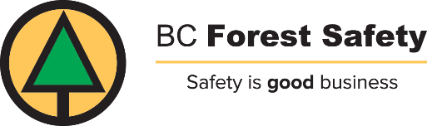
Managing Vegetation in Provincial Forests
The purpose of vegetation management is to promote the growth of important crop trees by delaying the growth of competing brush and trees of little commercial value.
Conifers such as Douglas-fir, hemlock, spruce, pine, cedar and fir are trees of high commercial value. Just like farm or garden crops, these trees need generous amounts of light, nutrients and water to grow well. Yet in the early stages of growth, many less valuable trees and most brush species provide strong competition for these essential ingredients. Their growth must be controlled.

Options for managing vegetation
There are five main options for controlling the growth of brush and trees of low commercial value:
- Manual methods use hand-held cutting tools such as chain saws, brush axes or girdling tools (used to remove bark from stems). One advantage is that they can be used selectively to treat individual trees and brush. However, manual methods are labor intensive and therefore, expensive. Often, they are effective for just a short time because cut trees and plants frequently re-sprout and may require retreatments. One of the biggest disadvantages of hand-held cutting tools is the high risk of injury from sharp blades. | 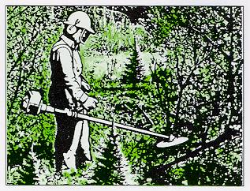
- Mechanical methods use heavy equipment such as crawler tractors with attachments for mowing, raking, crushing and chipping. Mechanical methods are used to clear large areas in a short time but they are usually limited to preparing sites for planting. Sometimes they can compact the soil or cause erosion. They seldom remove plant roots which usually re-sprout. | 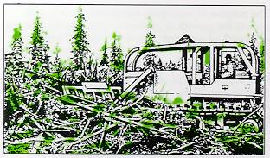
- Burning methods are widely used in B.C. to reduce slash and debris resulting from logging and to control undesirable vegetation before planting. Burning also improves access for planting crews and wildlife. It is the least expensive method of vegetation management but like manual and mechanical methods, it does not prevent re-sprouting of undesirable vegetation. | 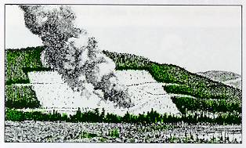
- Chemical methods use herbicides that are registered and approved for forestry use. They are usually applied through spraying or by injection. Herbicides often control competing plants long enough to allow the desired trees to dominate. Because fewer retreatments are required, chemical methods are generally less expensive than others. However, no single herbicides can be used to control all undesirable species. | 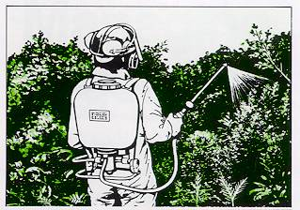
- Biological methods use livestock to control non-commercial vegetation. For example, sheep and cattle are used to graze on undesirable plants. This is an advantage to both the forests and the livestock. However, sheep and cattle can sometimes damage young crop trees. The need for retreatments, fencing, supervision and protection of livestock from predators, such as bears, make this method quite expensive. | 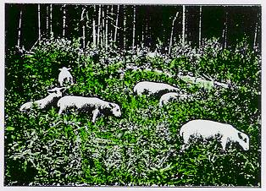

Which option for which site?
No single method of vegetation management suits all forest sites. Each site has its own specific characteristics and its own needs.
Forest managers study each site and decide what method of vegetation management will work best. The forest managers may choose a combination of two or more methods, taking into account many considerations.
First they decide exactly what vegetation should be controlled and why. They need to know what degree of control is necessary to favor the growth of preferred trees. They must also decide how fast and how long this control is needed.
Forest managers study characteristics of the forest site, such as size, accessibility, terrain and the susceptibility of soil to erosion or compaction. For instance, forest managers may find that the terrain is too steep for workers to do manual cutting or that the soil is too easily compacted or eroded to use mechanical methods.
Other resource uses are considered when forest managers choose a method of vegetation management. There may be lakes, rivers or streams in the area to protect, and fish and wildlife habitat to maintain. There may be popular hunting or trapping areas, or aesthetic areas to preserve.
Another important consideration is the health and safety of both the public and the forest worker. Forest managers will not undertake any method of vegetation management that places the worker or the general public in danger.
The choice of method of vegetation management also depends on very practical matters such as the availability of labor, equipment and money to do the job. Any choice must recognize and observe legal or policy restrictions as well.

What is being done?
Vegetation management is being practiced on forest lands throughout B.C. as an integral part of the overall silviculture program. Efforts are being made to:
- return land that is overgrown with brush to productivity;
- protect replanted sites currently threatened by competition from brush; and
- minimize future vegetation problems on newly harvested sites.
Vegetation management is essential for the establishment and rapid growth of B.C.'s most commercially valuable trees. Because it enables the forests to reach maturity in a shorter time, vegetation management will have a significant effect on the future economy of B.C.

