Workplace Hazardous Materials Information System (WHMIS) Policy
Reference: WorkSafeBC OHSR Part 5 Chemical Agents and Biological Agents, WHMIS 5.3 – 5.19
Note: Canada has implemented a revised WHMIS system which aligns with the Globally Harmonized System of Classification and Labeling of Chemicals (GHS).The new WHMIS is referred to as WHMIS 2015. The previous system was known as WHMIS 1998. Basic employer/employee responsibilities remain the same. More importantly, Acetylene is still flammable.
During the transition period, WHMIS 1988 and/or WHMIS 2015 may be used in the workplace.
Link to WHMIS 2015 fact sheet: www.ccohs.ca/products/publications/WHMISafterGHS.pdf.
Important words that change between WHMIS 1998 and WHMIS 2015
WHMIS 2015 – new | WHMIS 1998 – old
Hazardous Product | Controlled Product
SDS – Safety Data Sheet | MSDS – Material Safety Data Sheet
The Workplace Hazardous Materials Information System (WHMIS) is a hazard communication system which includes labeling, safety data sheets, education and training. Its purpose is to reduce injury and disease resulting from exposure to products.
Safety Data Sheets will be kept [with our site supervisor’s first aid kit] and [a copy in the office].
[Position title] will be responsible for WHMIS requirements which include:
Maintaining an inventory of products.
Updating the inventory when there are new products are in the workplace.
Updating Safety Data Sheets when received from a supplier
Updating Safety Data Sheets when 3 years old or greater.
Changes to the inventory will be communicated at a monthly meeting or sooner if appropriate.
Emergency response to potential incidents involving products will be determined, communicated and periodically tested. Products stored on site which could impact the safety of emergency response will be communicated to local emergency response personnel. [Position title] will be responsible for emergency response requirements.
Workplace labels using the exact product name from the manufacturer label must be applied on secondary containers where the product has been transferred from the original container and on containers of products produced on site.
Since our workplace contains products that meet both systems, then we must meet the requirements of both systems, including education and training.
WHMIS education will be provided [as part of a worker’s orientation] and if there is a change such as we receive a product that has an SDS and WHMIS 2015 label.
WHMIS training will be provided by a supervisor or other qualified person for workers required to use, or potentially be exposed to, products.
Education and training will include:
- The hazard classes, pictograms, and labels for both systems
- Their required elements, such as signal words (new in 2015)
- The meaning of all signal words and hazard statements found on labels and MSDSs/SDSs in the workplace
- The MSDS/ SDS format and how to locate information needed to work safely with a product
- Worksite-specific training on measures to work safely with hazardous products
In addition, as part of a [worker assessment] we will evaluate the knowledge of workers using
[written tests and practical demonstrations].
There are four basic questions to ask:
- How can this product hurt me?
- How do I protect myself?
- What should I do in an emergency?
- Where do I get more information?
Educational materials are included in the next few pages. The information is not all inclusive. We have a copy of “WHMIS: The Basics” for WHMIS 1998 published by WorkSafeBC and “WHMIS 2015 Fact Sheets” published by CCOHS in our [shop] in [the safety data sheet binder]. In addition, WorkSafeBC OHSR Part 5 Chemical Agents and Biological Agents, WHMIS 5.3 – 5.19 can be accessed from [our office computer].
An annual WHMIS review will be included in [our start-up meeting].

WHMIS 1998
Source: WorkSafeBC
Excerpts from “WHIMS: The Basics” (WorkSafeBC 2005 edition).
There are six hazard classes and eight hazard symbols that identify the specific hazards. (There are three symbols in Class D.) The eight hazard symbols identify the specific hazards of controlled products:

Hazard Classes and Pictograms
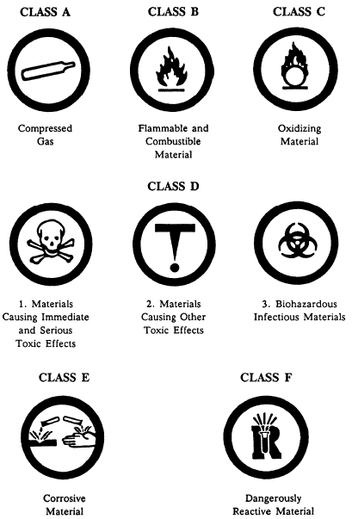

Supplier Label
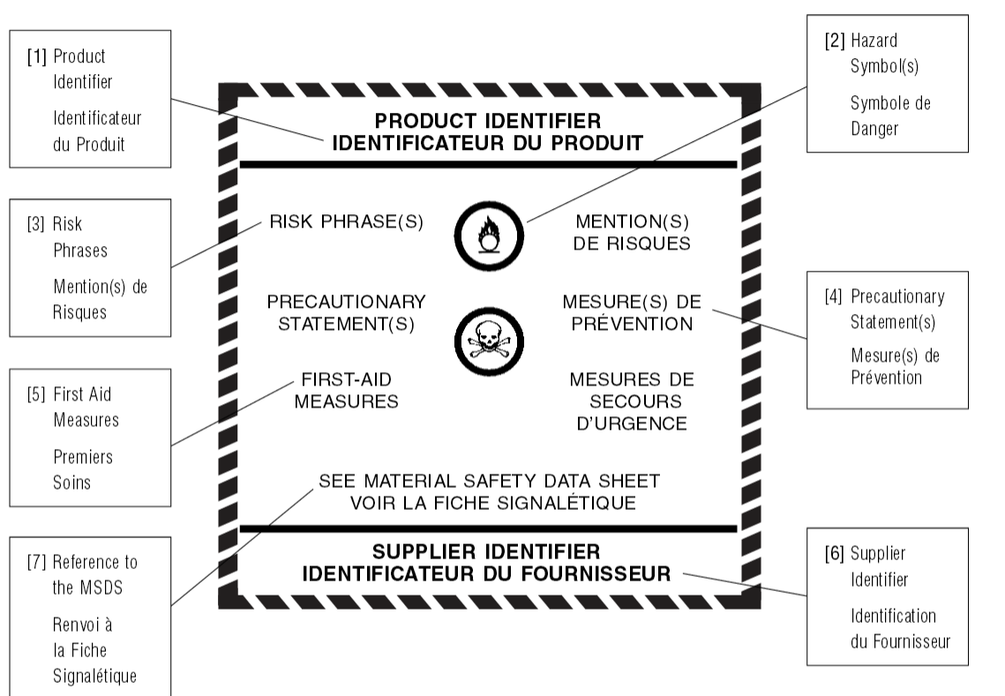

Material Safety Data Sheets
There are nine recommended headings for Material Safety Data Sheets.
Recommended headings:  Section 1 — Product Information  Section 2 — Hazardous Ingredients  Section 3 — Physical Data  Section 4 — Fire and Explosion Data  Section 5 — Reactivity Data  Section 6 — Toxicological Properties  Section 7 — Preventive Measures  Section 8 — First Aid Measures  Section 9 — Preparation Information | Additional sections that may be included:  Section 10 — Stability and Recovery  Section 11 —Toxicological Information  Section 12 — Ecological Information  Section 13 — Disposal considerations  Section 14 — Transport Information  Section 15 — Regulatory Information  Section 16 — Other Information

WHMIS 2015
Source: Canadian Centre for Occupational Health and Safety (CCOHS)
Publications: CCOHS WHMIS 2015 Fact Sheet and poster. The text and images in this section are primarily excerpts from these publications.

Worker Education and Training
Employers are required to educate and train workers about WHMIS 2015. Revised education and training programs, developed in consultation with the health and safety committee (if applicable), will include:
• New hazard pictograms.
• New hazard classes.
• New labels and their required elements such as signal words.
• The meaning of all signal words and hazard statements found on labels and SDSs in the workplace, such as Danger - May cause cancer.
• The new SDS format and how to locate information needed to work safely with a product.
• Worksite-specific training on measures to work safely with hazardous products.
Pictograms and Hazards (CCOHS poster. www.ccohs.ca/products/posters/WHMIS2015)
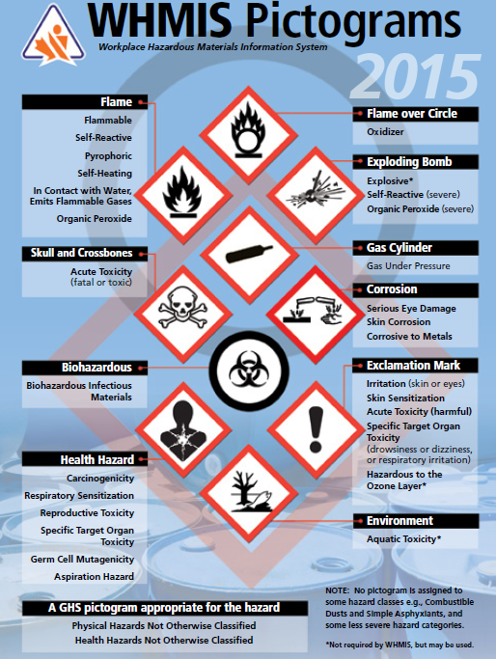

Supplier Labels
New requirements for supplier labels include signal words, and standardized hazard statements and precautionary statements.
Most hazard classes and categories have a prescribed signal word, hazard statement and pictogram. Supplier labels continue to be required in both English and French. See the WHMIS 2015 Supplier Labels Fact Sheet for further information.
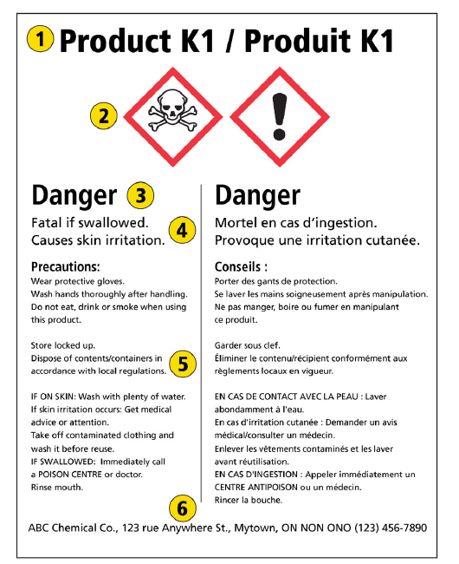 | 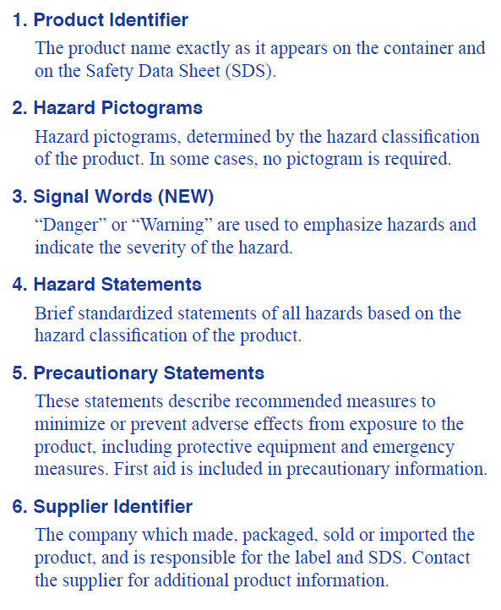

Safety Data Sheets (SDSs)
SDSs must follow a standard 16-section format. There are some new information requirements, for example, inclusion of the WHMIS classification, hazard statements and other label elements.
Worker access to SDSs is required. Ensure that updated SDSs are obtained for all hazardous products used in the workplace.
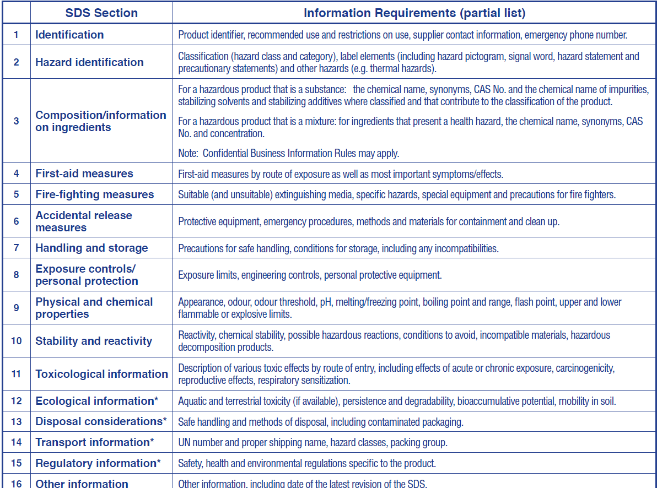

Physical and Health Hazard Classes
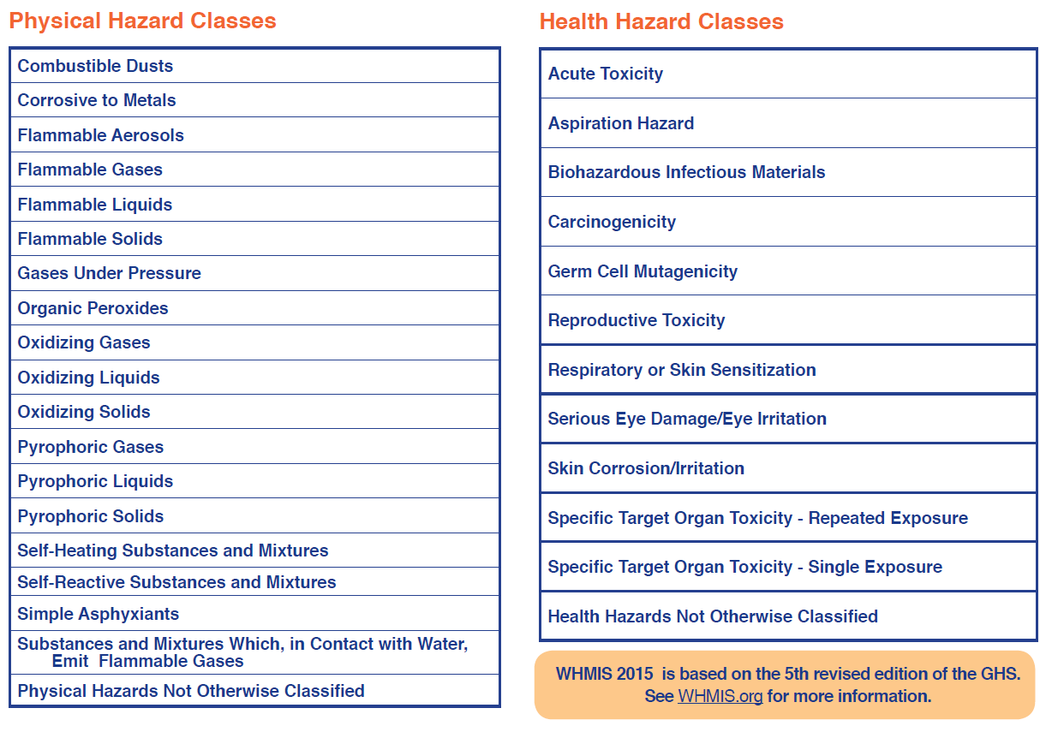
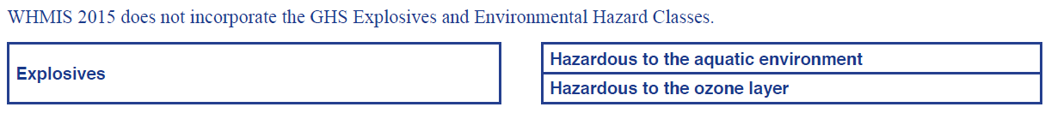

Our Inventory
Product Name | Location | Use | Safety Data Sheet  Date

WHMIS 1998 and WHMIS 2015 Quiz
- The new WHMIS 2015 has basically the same responsibilities for workers as WHMIS 1998.
True False
- The four basic questions I need to ask are:
  - _________________________________________
  - _________________________________________
  - _________________________________________
  - _________________________________________
- In WHMIS 2015 one of the two signal words will be included on a product label. The signal words are:
  - _______________
  - _______________
- What hazard is identified by this 2015 pictogram:
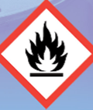 _____________________.
- What hazard is identified by this 2015 pictogram:
 ____________________.
- Our safety data sheets are kept in __________________________.
- Safety data sheets information includes (list 3 things) __________ __________ _________.
- Before working with a controlled product (WHMIS 1998)/ hazardous product (WHMIS 2015) I must receive worksite-specific training on measures to work safely with products.
True False

Answer Key
- True
- There are four basic questions to ask:
- How can this product hurt me?
- How do I protect myself?
- What should I do in an emergency?
- Where do I get more information?
- Danger, Warning
- Flammable (or also, self-reactive, pyrophoric, self-heating, organic peroxide or ‘in contact with water emits flammable gases’)
- Gas under pressure ( or Compressed Gas)
- Give correct answer for the company situation
- Any three of:
- True

