Functional Abilities Assessment Form
A Worker’s Information (completed by RTW Coordinator or employee)
Employee’s Surname | First Name |  | Occupational  Non-Occupational | Date of Injury / Illness |  | Unit
Employee’s Job Title |  | RTW Coordinator Name:  Tel. No. ( ) - Fax. No. ( ) - |  |  | Today's Date
It is the intention to assist our employees to safely return to their regular duties as soon as medically practical. In doing so, we are able to offer the employee modified duties as a means to transition to their regular duties. The following will assist in this process.
B Assessment (Part B, C and D to be completed by attending physician)
Due to injury or illness this employee has: Normal functional Abilities (Fit for Regular Duties) Reduced Functional Abilities
(No additional information needed. Please sign section E) (Please complete Section C , D & sign section E)

C Functional Abilities: (If unable to test, please estimate)
Step 1 Please circle the appropriate letter(s) &  Body area(s) to indicate the affected area(s) | Step 2 Please indicate  Reduced abilities |  | Step 3 Please indicate extent of abilities |  |  |  |  | Comments
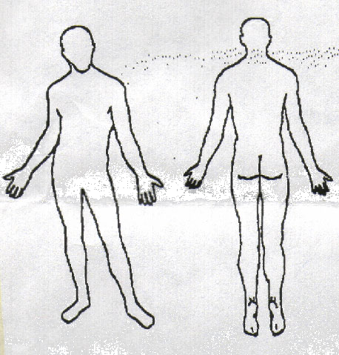  A Systemic or Non-Physical  B Head (incl. Vision, hearing, speech)  C Neck  D Upper back, chest, upper abdomen  E Lower Back  F Lower abdomen  G Shoulder or upper arm  H Elbow or lower arm  I Wrist or hand  J Hip or upper leg  K Knee or lower leg  L Ankle or foot  M Respiratory/Aerobic | Walk |  | Maximum Duration (hours): 1 2 4 5+ Other  Short distances only No walking
 | Stand |  | Maximum Duration (hours): 1 2 4 5+ Other
 | Sit |  | Maximum Duration (hours): 1 2 4 5+ Other
 | Lift/Carry  Floor – waist  Waist – shoulder  Above shoulder |  | Occasionally | Weight (kg)  21 16 9 |  | < 9kg - Specify
 |  |  |  | 21 16 9
 |  |  |  | 21 16 9
 | Bend/Twist  Neck  Back |  | Occasionally | Not at all |  | Specify
 | Push/pull  Moderate load  Light load |  | Occasionally | Not at all |  | Specify
 | Climb  Flight of stairs  Few steps |  | Occasionally | Not at all |  | Specify
 | Reach  Above shoulder  Below shoulder |  | Occasionally | Not at all |  | Specify
 | Use Hands For:  Writing  Typing  Fine manipulation  Grasping |  | Occasionally  L R  L R  L R  L R | Not at all  L R  L R  L R  L R |  | Specify
 | Sensory  Specify: |  | To See | To Hear |  | To Speak |  | To Maintain Balance
 | Operate Equipment |  | Specify:
 | Hours of Work |  | Specify: Normal hours or graduated RTW?
 | Prescription medication |  | Will it affect ability to work/drive:
Other Comments/Instructions (NO DIAGNOSIS OR TREATMENT):
D Normal functional abilities may resume in: 1-3 days 4-7 days 8-14 days Specify:
*Other: Employee is not medically fit for regular duties, will require periodic reassessments for effective rehabilitation. |  |  |  |  |  |  | Scheduled reassessment date for:
This authorizes my attending physician to provide the information requested above to COMPANY NAME |  |  |  |  | Employee's Signature: |  |  |  | Date:
E Physician's name & address: |  | Physician's Signature:
 |  | Physician's Telephone No:
 |  | Date:

