Introduction:
This assessment was conducted in consultation with (Supervisor) and assistance by (Millwright), (Electrician) and (Operator). It covers routine cleaning, inspecting and maintenance/repairs to the Baler Cross Conveyor Collection Vault
Description:
The Baler Cross Conveyor Collection Vault is part of the Wood Shaving Baler process where-by residual SPF (Spruce/Pine/Fir) wood shavings from a local sawmill are conveyed to a baler where the are compression packaged for sale as animal bedding material. It is located on the ground floor beneath the Shaker.
The Cross Conveyor collects wood shavings from the outfeed of a shaker that removes wood fines, by screening, from the shavings. The Cross Conveyor (pictured below) measures approximately 1.5m x 1.7m x 1m = 2.55m³ volume (90 ft³). The shavings are then conveyed up to the Baler Infeed Hopper.
The vessel is constructed of carbon steel and has a concrete floor. There is no vessel lining or any other construction material in the space such as plastic or insulating brick. There is a ventilation system on top of the space which pulls airborne fines into a collection system.
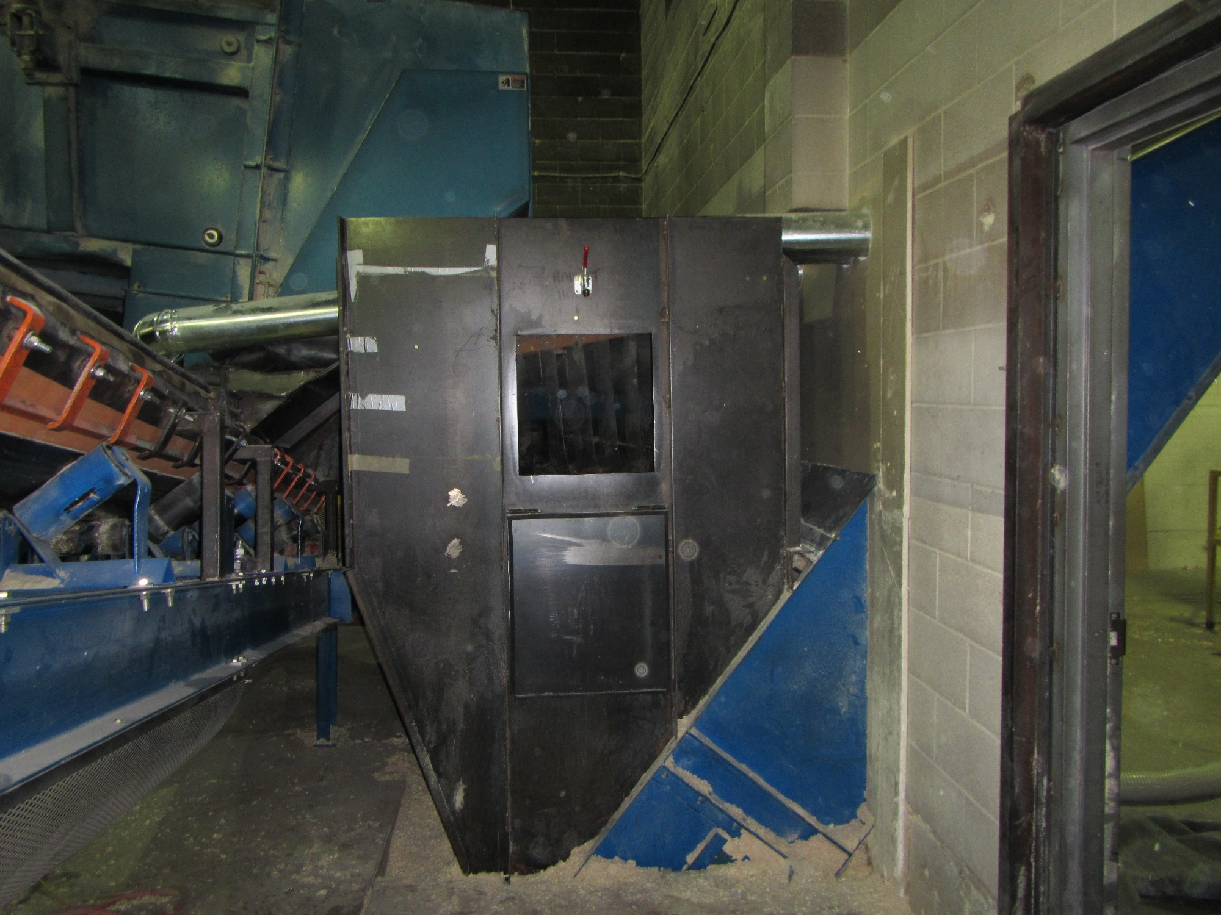
Baler Cross Conveyor

Confined Space Determination:
WorkSafeBC Regulation 9.1 defines a confined space of having four characteristics.
WSBC Criteria | Baler Cross Conveyor
Is enclosed or partially enclosed | YES
Is not designed or intended for continuous human occupancy | YES
Has limited or restricted means for entry or exit that could complicate the provision of First Aid or Rescue | YES
Is large enough and so configured that a worker could enter to perform assigned work | YES: entry via a small hatch in the side of the unit

By the definition in WSBC Reg 9.1 the Baler Cross Conveyor Collection Vault is a confined space.

Hazard Identification and Risk Assessment for Entry into the Baler Cross Conveyor Collection Vault for the purposes of:
- Cleaning, Inspection and Unplugging the Conveyors
- Mechanical Repairs to the conveyor systems which may include welding carbon steel.
Pre-Existing Conditions:
Intended use of space is to collect and then transfer SPF Wood Shavings.
Space Infeed:
- Spruce/Pine/Fir residual shavings that have had most of the sawdust fines removed by a shaker screen. A chain conveyor feeds the shavings and the conveyor bars impinge into the space.
- No other associated process piping or ducting into the space.
Space Outfeed:
- SPF Shavings are conveyed out of the space by a chain conveyor that is inside the bottom of the space.
- A dust collection ventilation system provides general exhaust by pulling air from the space.
Atmospheric Hazard:
- The vessel is not sealed so there is no risk of oxygen depletion due to rust or biological activity.
- There is steady flow of ambient air through the system facilitated by the dust collection system so no pockets of stagnant air can develop.
- The conditions in the vessel will not promote decomposing of organic material that could generate toxic or flammable gases such as H₂S or Methane.
- No Chemicals or other potentially hazardous materials are introduced into the space by the process or anticipated work activities.
- There are no internal combustion engines or combustion processes near the space that could result in contaminants entering the space.
- Carbon Steel welding operations will introduce metal fume into the space. If welding is required then local exhaust ventilation must be used and workers in the space must wear a respirator with HEPA cartridges, and guard against welding flash. The dust collection ventilation must be shut down when welding to prevent sparks from starting a fire in the dust collection system.
- Wood dust will be present in the space. The WSBC exposure limit for non-allergenic wood dust (SPF) is 2.5 mg/m3. A water mist and/or wet wiping to supress dust is required for entry without respiratory protection. Safety eyewear and a ½-face respirator with P100 cartridges or a full-face respirator with P100 cartridges are required when first opening the space due to the presence of wood dust, and while performing dust suppression.
- Excessive wood dust in the space could be a fire or explosion hazard. When opening the space do not generate sparks and keep all ignition sources away from the space. Ensure that dust suppression and fire safety measures (hot work permit, ventilation control, welding blankets) are employed when welding, cutting or grinding).
Oxygen levels inside the Baler Infeed Hopper must be 21% by volume for entry into a space without special respiratory protection precautions. Oxygen levels less than 20% or greater than 22% are considered unusual for this space and entry is not allowed until oxygen levels can be confirmed as normal (21%).
Contaminants must be controlled to less than the 8 hour TWA exposure limit for entry into a space without respiratory protection. Combustible vapours and gases must be undetected for entry into the space.
Ventilation was examined and during regular cleaning and inspection the Main Dust Cyclone Ventilation system should remain running to provide airflow through the space. Local exhaust ventilation is required if welding, cutting, burning or grinding is done.
General forced air ventilation of 30cfm will provide 20 air changes per hour inside this 90ft³ space. However, supplying forced air ventilation will elevate dust levels, so as long as air monitoring confirms clean fresh air then forced air supply ventilation is not recommended
Based on the process (conveying SPF wood shavings) and the inputs into this space, it is expected to contain a low hazard atmosphere. Gas testing for Oxygen and Combustible gas/vapours are required over a period of time to confirm this assessment.

Mechanical Hazards - Engulfment or Entrapment:
Cross transfer conveyor presents a risk of entrapment. Controlled by de-energizing and locking out the screen transfer belt conveyor (stn. #B3)
The BM&M Screen (Shaker) infeed presents a risk of overhead hazard and possible mechanical injury (struck by). Controlled by de-energizing and locking out the BM&M Screen (Shaker) (stn. #B2)
The Baling Incline Chain Conveyor that transports material out of the Baler Cross Conveyor Collection Vault presents a risk of entrapment or mechanical injury (struck by). Controlled by de-energizing and locking out the Baling Incline Chain Conveyor (stn. #B5).
First Aid, Rescue and Evacuation:
The Baler Cross Conveyor Collection Vault presents a risk in relation to First Aid, rescue, or evacuation of workers inside the space. Summoning first aid or rescue will be accomplished by providing the workers inside the space with a radio capable of contacting the first aid attendant. The facility has a Level 3 First Aid Attendant qualified to package a patient for transport to hospital and get them out of the space.
Electrical Hazards
There are no electrical hazards inside the space. Motor cables are in the area and workers must be aware of them and be careful not to cut into electrical cables.
Electrically powered tools present a risk of electric shock. This will be controlled by using GFCIs with all electrical tools.
Mechanical Hazards:
The configuration of the space presents a risk of slip, trip and fall. Workers must exercise caution, identify hazards, and if possible pad protruding edges.
Tools and equipment must be inspected for good working order to prevent mechanical injury
Stored Potential/overhead Hazards:
There are no loaded springs or hydraulic/pneumatic pressure systems inside the space.
There are no inherent overhead hazards other than the BM&M Screen (SHAKER) which is controlled by locking out.
Other workers must be aware of work inside the space so as not to create an overhead hazard, such as a crane lift.
Chemical Hazards
There are no chemical hazards inherent to the Baler Cross Conveyor Collection Vault. The cleaning and maintenance operations described by workers will not introduce hazardous chemical agents into the space.
Metal particulate and fume from welding, cutting and grinding will be controlled by using local exhaust ventilation and respiratory protection (1/2 face respirator with HEPA cartridge).

Noise and Vibration
The space has a reverberant surface and noise and vibration will be amplified inside the space. This is controlled by using hearing protection when using power tools or impact tools inside the space.
Lighting
There is insufficient light inside the space, which presents a risk of mechanical injury (trip, fall, stuck-by and stuck-against). Lighting must be provided to ensure adequate visibility for workers. Lighting should be protected from breakage to prevent an exposed ignition source.
Ergonomics:
The space is configured in such a manner as to require awkward work postures. Workers must be aware of the symptoms of MSI and take micro stretch breaks as necessary.
Heat and Cold
The temperature of the space is the same as the ambient environment. No special requirements

The Baler Cross Conveyor Collection Vault is a moderate risk confined space by virtue of the risk of entrapment that requires isolation and lock out. The atmosphere may be classified as low risk after a period of time where representative sampling for oxygen, and combustible gases/vapours confirm clean respirable air.
A permit is required for entry into the Bale Cross Conveyor which must include a safety checklist with lock out procedures.

END

